**KALLAM HARANADHAREDDY INSTITUTE OF TECHNOLOGY**

**PROJECT TITLE**

**A CRM APPLICATION TO MANAGE THE BOOKING OF CO-LIVING**

Team Members

Patchala Akshay

[218x1a4273@khitguntur.ac.in](mailto:218x1a4273@khitguntur.ac.in)

Vaddadi Sai Teja

[218x1a42a4@khitguntur.ac.in](mailto:218x1a42a4@khitguntur.ac.in)

Shaik Sohail

[218x1a4295@khitguntur.ac.in](mailto:218x1a4295@khitguntur.ac.in)

Naladala Surya Vamshi Krishna

[218x1a42b7@khitguntur.ac.in](mailto:218x1a42b7@khitguntur.ac.in)

Shaik Shabbir

[218x1a4294@khitguntur.ac.in](mailto:218x1a4294@khitguntur.ac.in)

**Project Abstract**

The **CRM Application for Managing Co-Living Bookings** is designed to streamline the reservation process, enhance customer interactions, and optimize space utilization for co-living operators. This system provides an intuitive interface for tenants to browse, book, and manage their stays while offering administrators a centralized dashboard for handling reservations, payments, and customer communications. Key features include **real-time availability tracking, automated booking confirmations, secure payment integration, and data-driven insights to improve operational efficiency.** With a focus on scalability and security, the application ensures seamless management of co-living spaces, reducing manual workload and enhancing the overall tenant experience.

**INDEX**

1. Introduction
2. Objective
3. Implementation

* **3.1 Salesforce**
  + Creating Developer Account
  + Account Activation
* **3.2 Object Creation**
* To Create a Custom Object for Total Rooms
* To Create a Custom Object for Customer
* To Create a Custom Object for Room Booking
* To Create a Custom Object for Payment
* To Create a Custom Object for Food Selection
* To Create a Custom Object for Feedback
* **3.3 Tabs**
* Creating a Tab for Total Rooms
* Creating a Tab for Customers
* Creating a Tab for Room Bookings
* Creating a Tab for Remaining Objects
* **3.4 The Lightning App**
* Creating a Lightning App
* **3.5 Fields & Relationships**
* Creating Fields for the Customer1 Object
* Creation of Fields & Relationship for Payment1 Object
* Creation of Fields for the Food Selection Object
* Creation of Fields for the Feedback Object
* Creation of Fields for the Total Rooms Object
* **3.6 Validation Rule**
* To Create a Validation Rule to An Room Booking Object
* Creating an another Validation Rule to An Room Booking Object
* **3.7 Profile**
* To Create a Custom User Profile
* To Create Custom Platform User1
* To Create Custom Platform User2
* **3.8 Roles**
* Creating a Marketing Role
* Creating a Receptionist Role
* **3.9 Users**
* Creation of an User
* Creation of an Another User
* Creation of an Another User
* **3.10 User Adoption**
* Creating a Record (Customers)
* Viewing a Record (Customers)
* Deleting a Record (Customers)
* **3.11 Reports**
* Creating a Report
* Creating another Report
* **3.12 Dashboards**
* Creating a Dashboard
* Creating another Dashboard
* **3.13 Flows**
* Creating a Flow
* Testing the Flow

4. Outcomes

5. Challenges & Solutions

6. Key Scenarios Addressed for Salesforce on Implementation of Project

7. Conclusion

**INTRODUCTION**

The rise of co-living spaces as a modern housing solution has highlighted the need for an efficient and streamlined booking management system. Traditional methods of handling reservations, tenant interactions, and payments often lead to inefficiencies, mismanagement, and delays. To address these challenges, this project aims to develop **A CRM Application to Manage the Booking of Co-Living**, providing an automated, user-friendly, and data-driven solution for both tenants and administrators.

This **Customer Relationship Management (CRM) application** is designed to facilitate seamless booking processes, enhance customer engagement, and optimize operational efficiency. The system offers **real-time room availability tracking, automated booking confirmations, secure payment processing, and a centralized tenant management dashboard**. Additionally, it integrates communication tools to improve interactions between tenants and co-living operators, ensuring a smooth and hassle-free experience.

With a focus on **scalability, security, and usability**, this project aims to bridge the gap between traditional property management and modern digital solutions. The CRM application will help co-living space providers streamline their operations, reduce manual workload, and enhance tenant satisfaction, ultimately improving business efficiency and profitability.

**OBJECTIVES**

The primary objective of this project is to develop a CRM Application to Manage the Booking of Co-Living that enhances the efficiency, accuracy, and user experience of booking management. The specific objectives include:

1. **Automate the Booking Process** – Develop a seamless system for tenants to search, select, and book available co-living spaces in real time.
2. **Centralized Tenant Management** – Provide administrators with a dashboard to manage tenant details, track bookings, and handle inquiries efficiently.
3. **Real-Time Availability Tracking** – Implement a system to display up-to-date room availability, preventing overbooking and ensuring accurate reservations.
4. **Secure Payment Integration** – Enable online payment processing with multiple options, ensuring secure and hassle-free transactions.
5. **Data Analytics and Reporting** – Generate insights and reports on occupancy trends, booking patterns, and customer preferences to aid decision-making.
6. **User-Friendly Interface** – Design an intuitive and responsive interface for both tenants and administrators to improve user experience.
7. **Scalability and Security** – Ensure the system is scalable to handle increasing users and bookings while maintaining data security and privacy.
8. **Feedback and Rating System** – Implement a mechanism for tenants to provide feedback and rate their experience, helping co-living providers improve their services.

**IMPLEMENTATION**

**3.1 SALESFORCE**

Salesforce is a cloud-based Customer Relationship Management (CRM) platform designed to help businesses manage their customer data, sales, marketing, and service operations efficiently. It provides tools for automating processes, generating insightful reports, and enhancing customer interactions. The platform supports various industries, including e-commerce, by offering solutions for tracking transactions, managing customer interactions, and optimizing marketing strategies. Salesforce is highly customizable, allowing businesses to tailor the platform according to their specific needs.

For e-commerce activities, Salesforce CRM plays a crucial role in tracking customer purchases, managing sales pipelines, and analyzing buying behavior. With its powerful features such as workflow automation, reports, dashboards, and AI-driven insights, businesses can improve customer satisfaction, enhance operational efficiency, and boost sales. This project utilizes Salesforce to create a CRM solution specifically designed to streamline e-commerce transactions and optimize business decision-making.

**3.1.1 Creating a Developer Account**

1.Visit <https://developer.salesforce.com/signup> the S**alesforce Developer** website

2. Fill in the registration form with details such as name, email, company, username

3. Accept the **Salesforce Terms of Service** and click **Sign Up**.

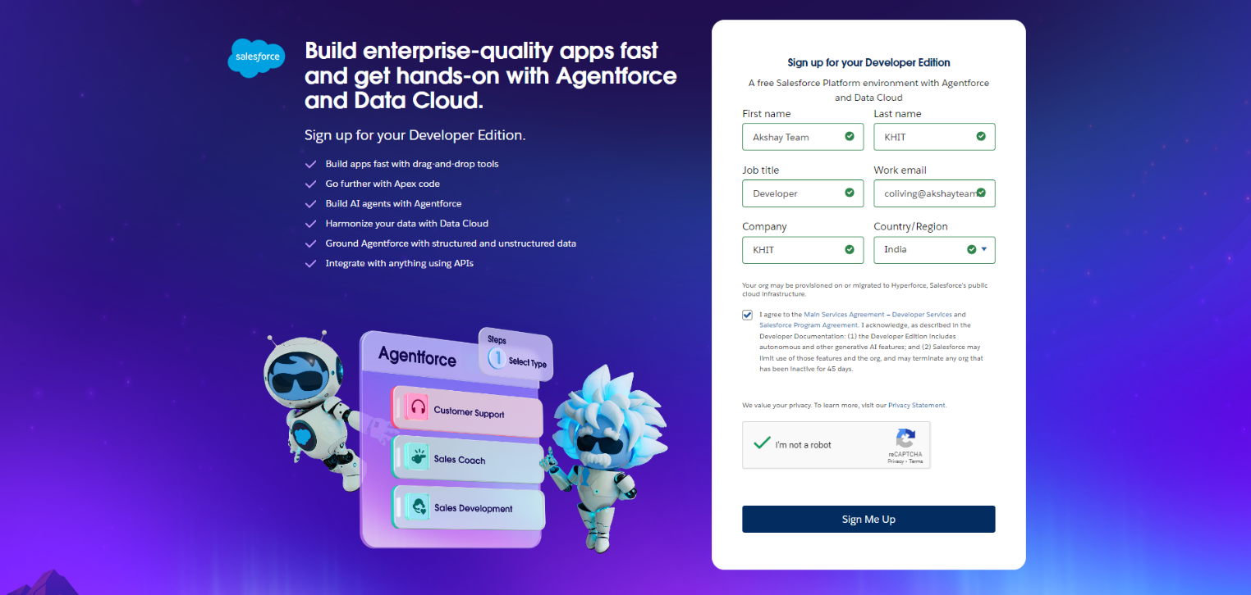

4. A confirmation email will be sent to the registered email ID.

5. Open the email and click on the verification link to activate the developer account.

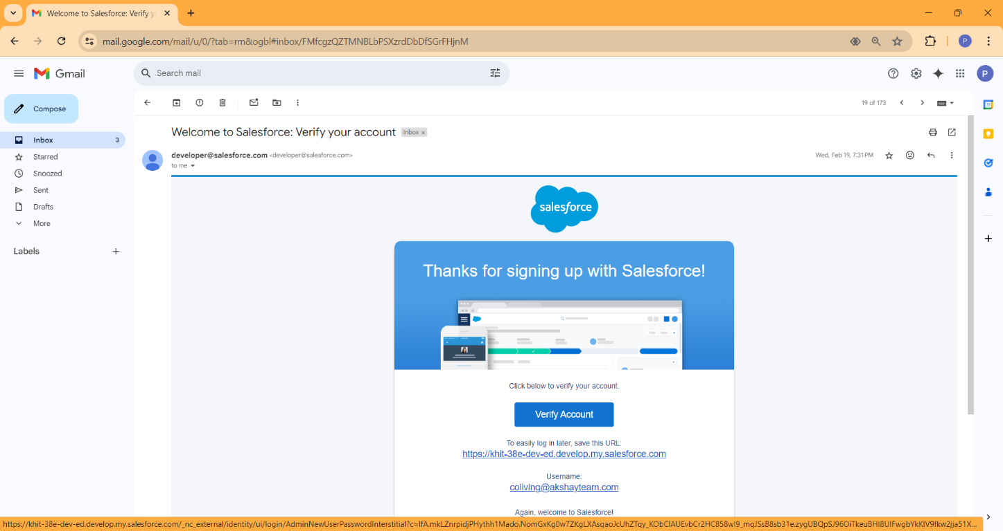

**3.1.2 Account Activation**

1. After verification, log in to **Salesforce Developer Edition** using the provided credentials.
2. Set up a **new password** and security question for future access.

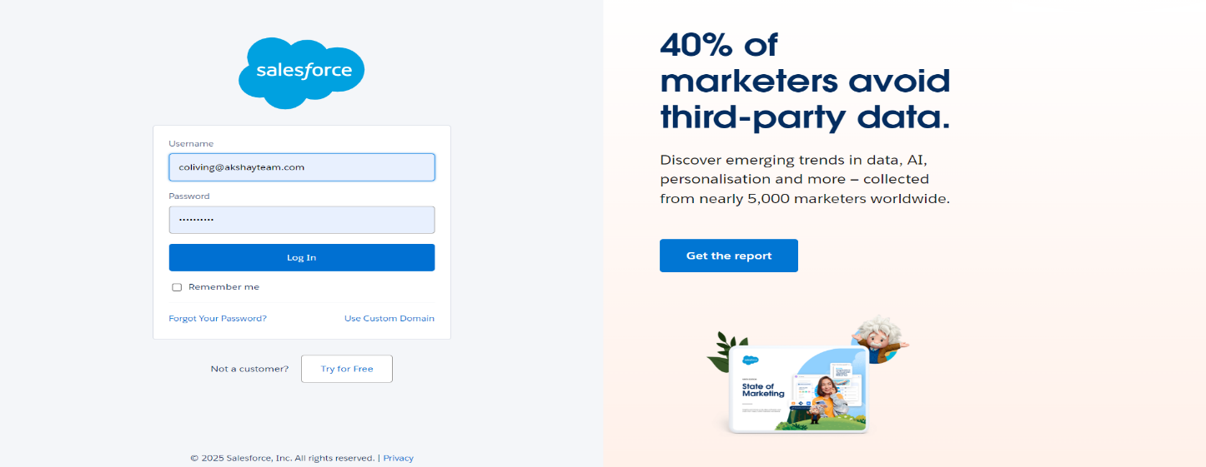

1. Once logged in, navigate to the **Salesforce Setup** page to begin configuring the environment.
2. Configure the **organization settings**, such as company information, currency, time zone, and language.
3. Start exploring the **Salesforce platform**, including Lightning Experience, Object Manager, and App Builder.

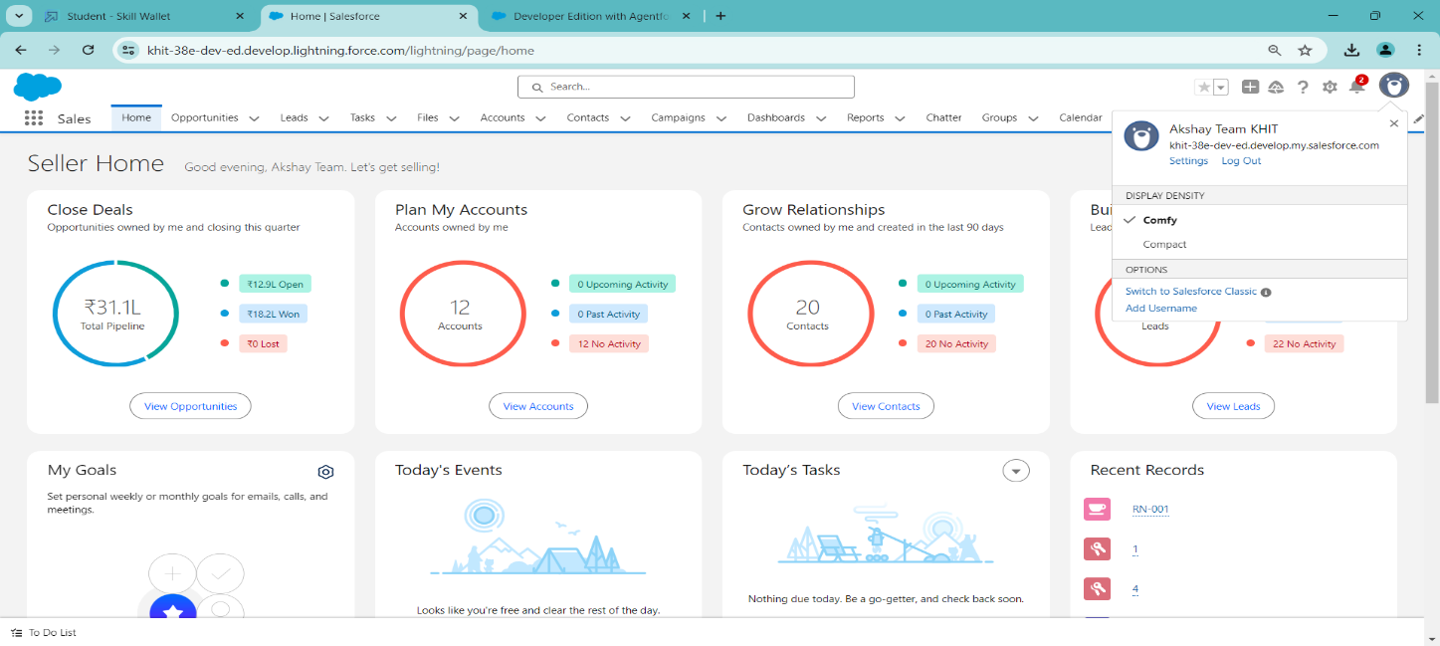

**3.2 Object Creation**

In Salesforce, objects are essential components that store and organize data. They act as database tables where different records are maintained. Objects can be **Standard Objects** (predefined by Salesforce) or **Custom Objects** (created based on business needs). For e-commerce applications, creating relevant custom objects is critical to managing transactions, customer information, and product details efficiently. By structuring data appropriately.

Custom objects in this project will be designed to store key e-commerce data such as transaction details, customer profiles, and item listings. These objects will be linked together through relationships, ensuring seamless data flow between different components of the CRM system. Below is a step-by-step guide for creating custom objects in Salesforce.

**Step-by-Step Process to Create Objects:**

1. To Navigate to **Setup page**
2. Click on gear icon **click setup.**
3. Click on **Object Manager**
4. Click on **Create**
5. Click on **Custom Object**.
6. On Custom object defining page
7. Enter the label name, plural label name, click on Allow reports and allow search

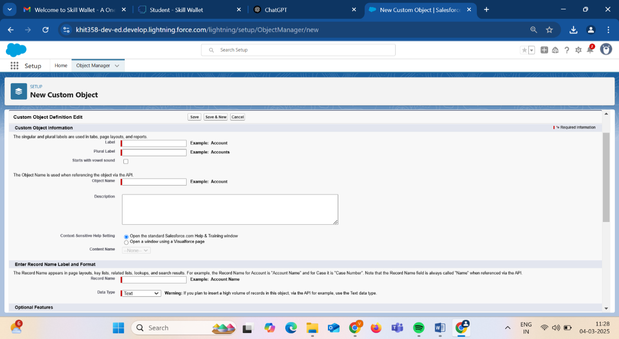

* + 1. **To Create a Custom Object For Total Rooms**

1. From the **setup page** -> Click on **Object Manager** -> Click on **Create** -> Click on **Custom Object**.

1) Enter the **label name**-> **Total Room**

2) Plural **label name**->**Total Rooms**

3) Enter Record Name Label and Format

**Record Name** -> **Total No Of Rooms**

**Data Type** -> **text**

1. Click on **Allow reports** and **Track Field History**
2. In the Deployment Status section, ensure **Deployed is selected**
3. Allow search ->**Save.**
4. In the Object Creation Options section, select Add Notes and Attachments related list to default page layout.

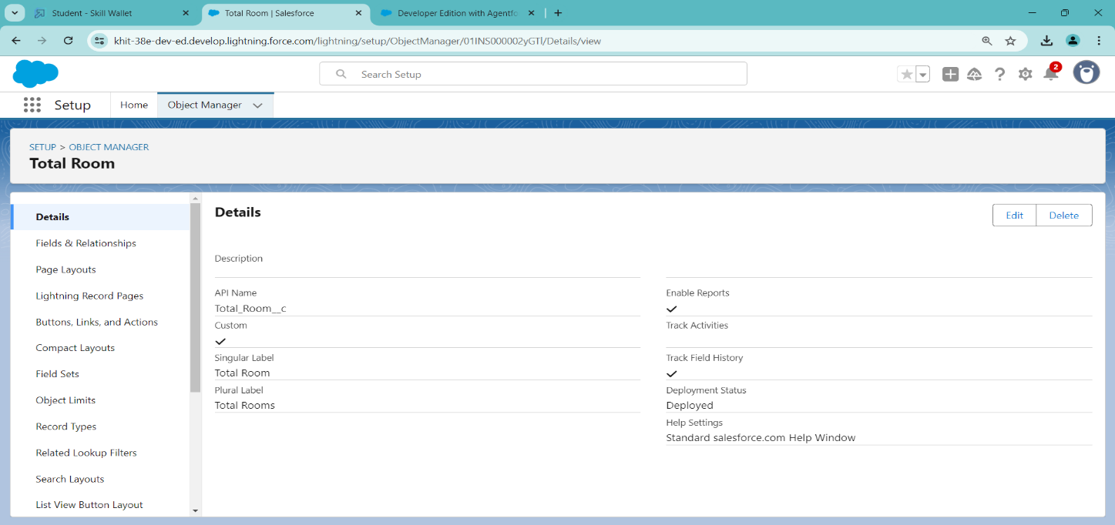

* + 1. **To Create a Custom Object For Customers**

1. From the **setup page** ->Click on **Object Manager** -> Click on **Create** -> Click on **Custom Object.**

1) Enter the **label name**-> **Customer1**

2) Plural label name-> **Customers**

3) Enter Record Name Label and Format

Record Name -> **Customer Name**

Data Type -> **Text**

1. Click on Allow **reports** and **Track Field History**,
2. Allow search -> **Save**.
3. In the Deployment Status section, ensure Deployed is selected.
4. In the Object Creation Options section, select Add Notes and Attachments related list to default page layout

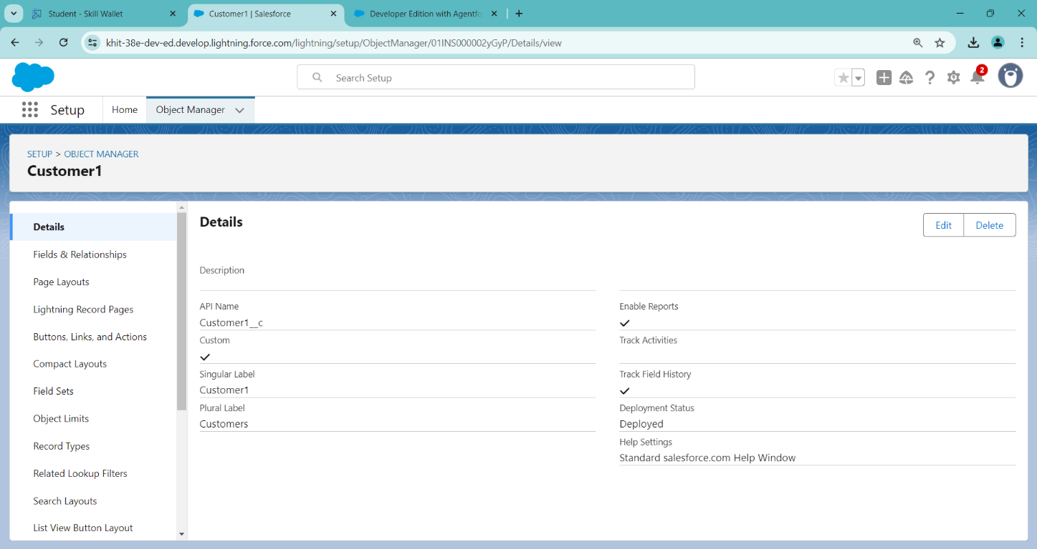

* + 1. **To Create a Custom Object For Room Booking**
  1. From the **setup page** ->Click on **Object Manager** -> Click on **Create** -> Click on **Custom Object.**
  2. Enter the **label name**-> **Room Booking**
  3. Plural label name-> **Room Bookings**
  4. Enter Record Name Label and Format
  5. Record Name -> **Room Number**
  6. Data Type -> **Auto Number**
  7. Click on Allow **reports** and **Track Field History**,
  8. Allow search -> **Save**
  9. Select the data type as "Auto number ".
  10. Under Display format enter RN-{000}
  11. Enter starting Number as 1
  12. In the Optional Features section, select Allow Reports and Track Field
  13. In the Deployment Status section, ensure Deployed is selected.

14. In the Search Status section, select Allow Searcn the Object Creation Options section, select Add Notes and Attachments related list to default page layout.

15. Leave everything else as is, and click Save.

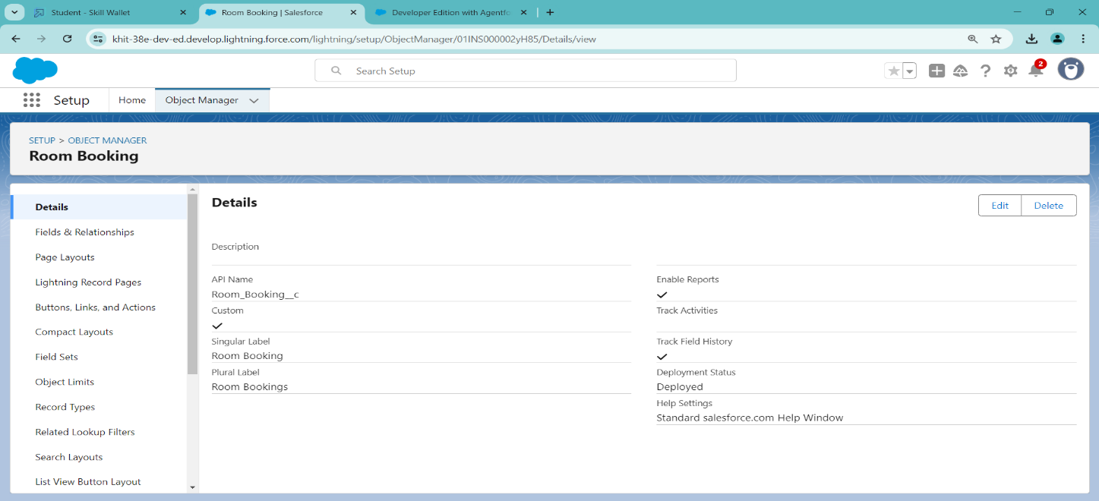

**3.2.4 To Create a Custom Object For Payment**

1. From setup click on object manager.
2. Click create, select custom object.
3. Fill in the label as " Payment1".
4. Fill in the plural label as " Payments ".
5. Record name: "Payment No "
6. Select the data type as "Auto number ".
7. Under Display format enter PNO-{000}
8. Enter starting Number as 1
9. In the Optional Features section, select Allow Reports and Track Field History.
10. In the Deployment Status section, ensure Deployed is selected.
11. In the Search Status section, select Allow Search.
12. In the Object Creation Options section, select Add Notes and Attachments related list to default page layout.
13. Leave everything else as is, and click Save.

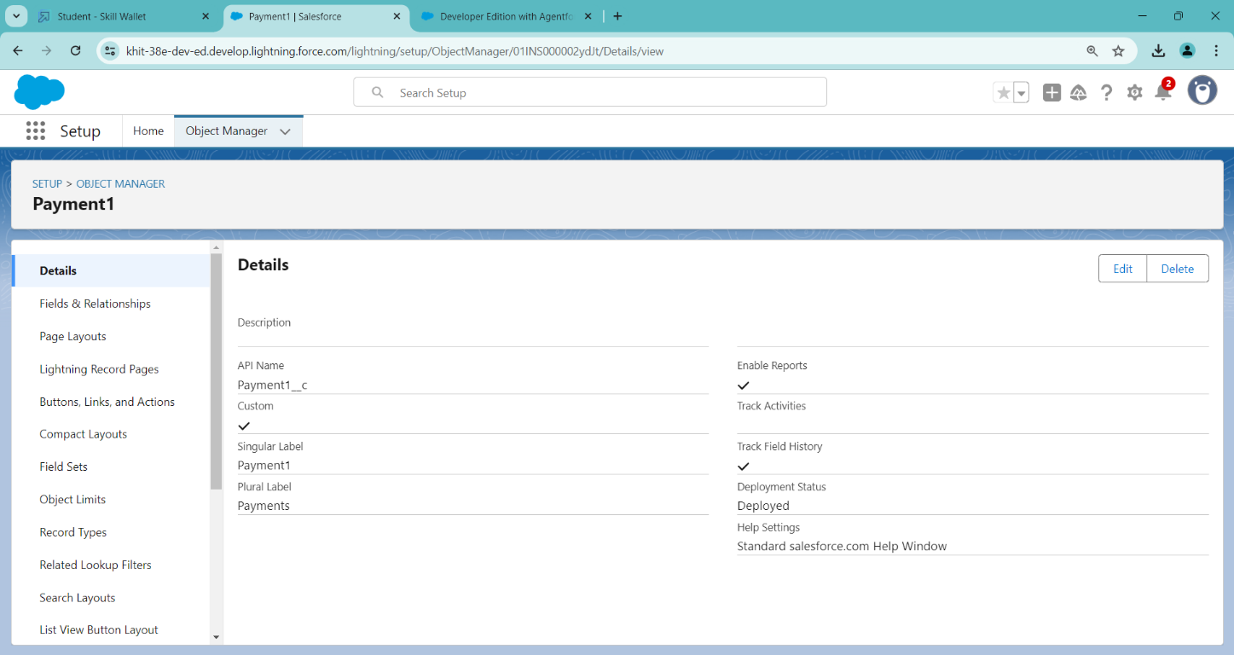

* + 1. **To Create a Custom Object For Food Selection**

1. From setup click on object manager.
2. Click create, select custom object.
3. Fill in the label as " Payment1".
4. Fill in the plural label as " Payments ".
5. Record name: "Payment No "
6. Select the data type as "Auto number ".
7. Under Display format enter PNO-{000}
8. Enter starting Number as 1
9. In the Optional Features section, select Allow Reports and Track Field
10. In the Deployment Status section, ensure Deployed is selected.
11. In the Search Status section, select Allow Search.
12. In the Object Creation Options section, select Add Notes, Attachments related list to default page layout.
13. Leave everything else as is, and click Save.

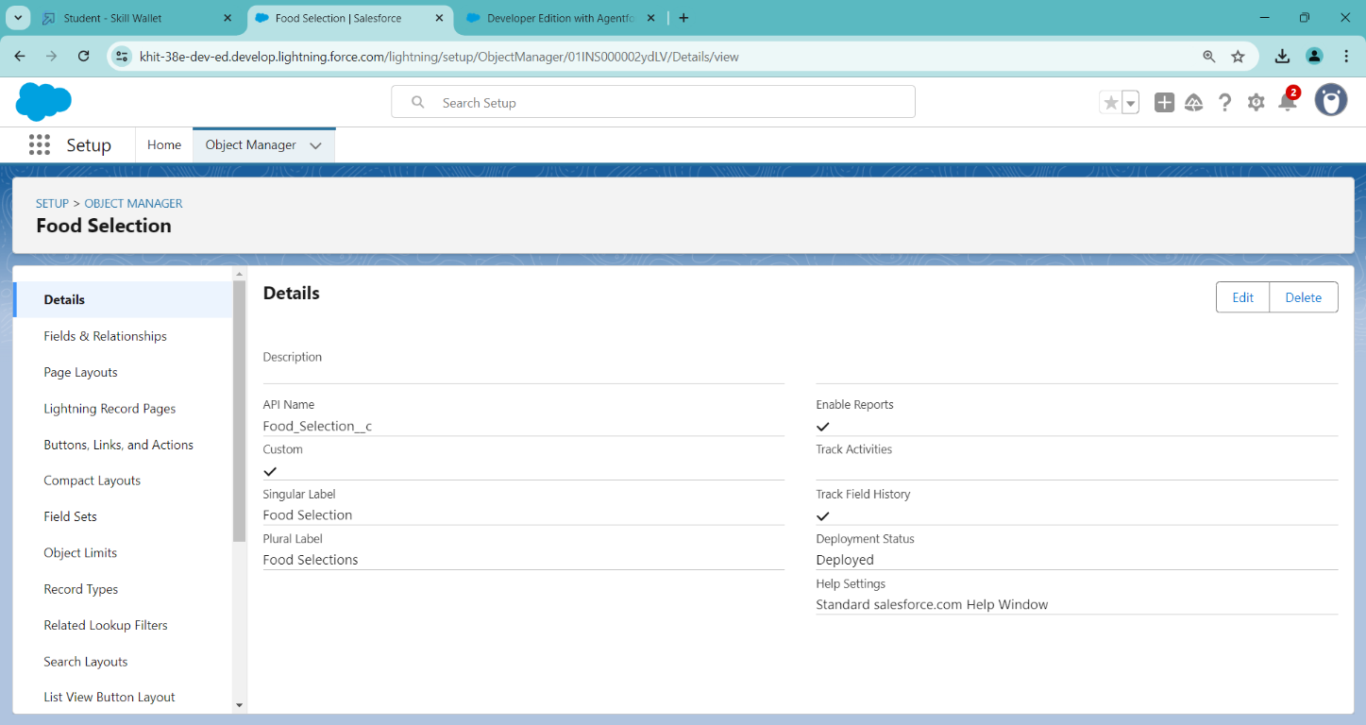

**3.2.6 To Create a Custom Object For Feedback**

1. From setup click on object manager.
2. Click create, select custom object.
3. Fill in the label as " Feedback ".
4. Fill in the plural label as " Feedbacks ".
5. Record name: "Feedback No "
6. Select the data type as "Auto number ".
7. Under Display format enter Fd No-{0000}
8. Enter starting Number as 1
9. In the Optional Features section, select Allow Reports and Track Field History.
10. In the Deployment Status section, ensure Deployed is selected.
11. In the Search Status section, select Allow Search.
12. In the Object Creation Options section, select Add Notes and Attachments related list to default page layout.

**3.3 Tabs**

Tabs in Salesforce serve as navigation points that allow users to access specific objects, records, and applications efficiently. Custom tabs are particularly useful in providing easy access to custom objects, ensuring that users can quickly enter, retrieve, and manage relevant data.

A tab is like a user interface that is used to build records for objects and to view the records in the objects.

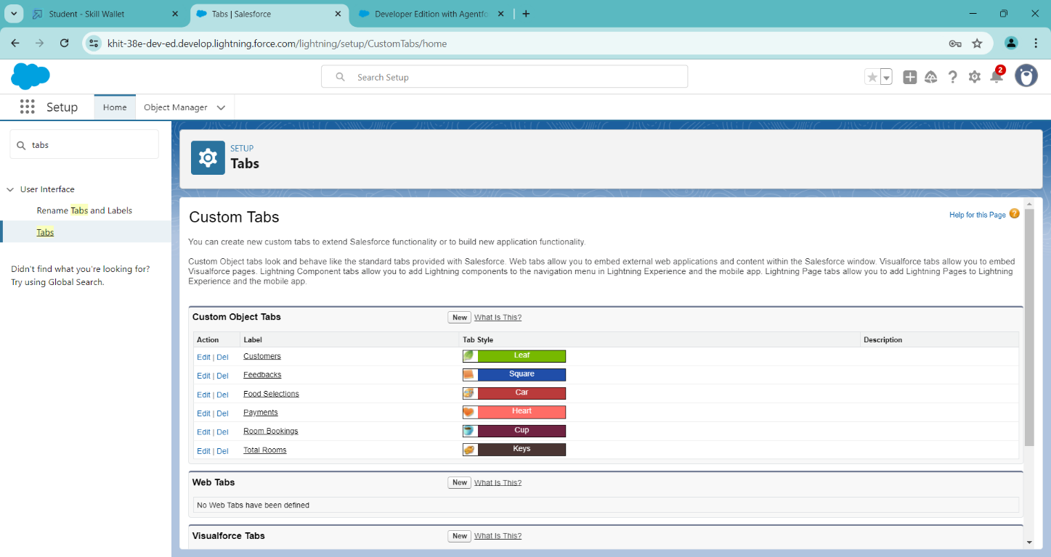

**Types of Tabs:**

* + 1. **Custom Tabs**

Custom object tabs are the user interface for custom applications that you build in salesforce.com.

* + 1. **Web Tabs**

Web tabs make it easier for your users to quickly access content and applications they frequently use without leaving the salesforce.com application.

* + 1. **Visualforce Tabs**

Visualforce Tabs are custom tabs that display a Visualforce page. Visualforce tabs look and behave like standard salesforce.com tabs such as accounts, contacts, and opportunities.

* + 1. **Lightning Component Tabs**

Lightning Component tabs allow you to add Lightning components to the navigation menu in Lightning Experience and the mobile app.

* + 1. **Lightning Page Tabs**

Lightning Page Tabs let you add Lightning Pages to the mobile app navigation menu.

**3.3.1. Creating a Tab for Total Rooms**

1. Go to setup page > type Tabs in Quick Find bar > click on tabs > New (under custom object tab)
2. Select Object(Total Rooms) > Select the tab style.
3. Next (Add to profiles page) keep it as default
4. Next (Add to Custom App) keep it as default & Save.

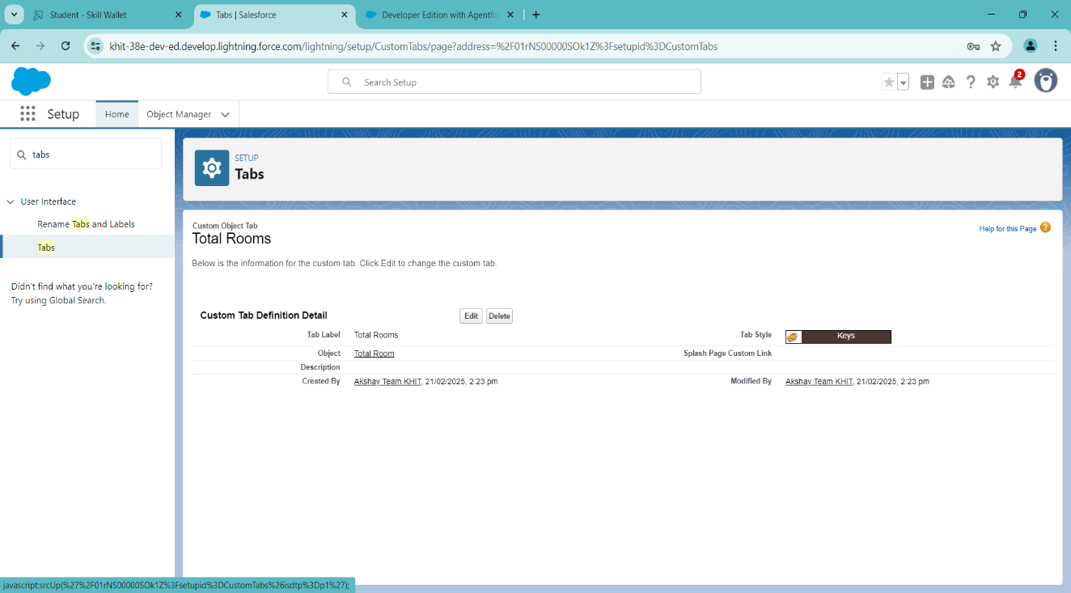

**3.3.2. Creating a Tab for Customers**

1. Go to setup page > type Tabs in Quick Find bar > click on tabs > New (under custom object tab)

2. Select Object(Customers) > Select the tab style > Next (Add to profiles page) keep it as default > Next (Add to Custom App) keep it as default > Save.

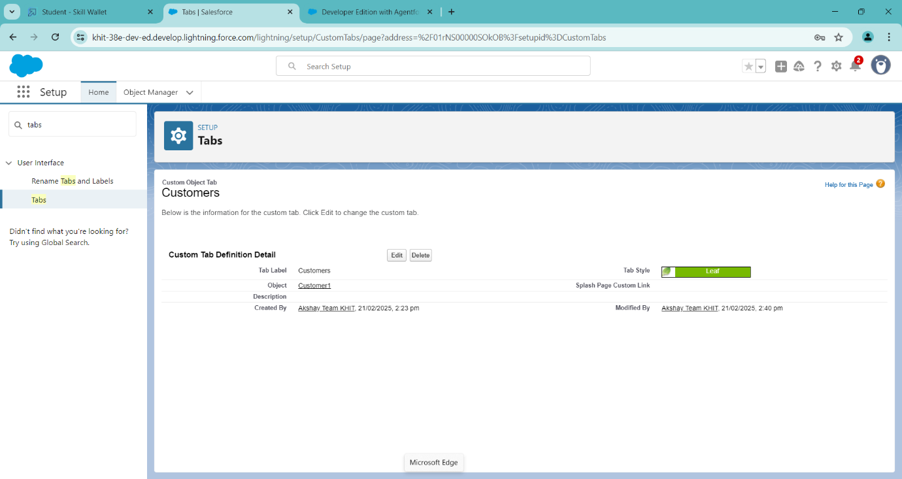

**3.3.3. Creating a Tab for Room Bookings**

1. Go to setup page > type Tabs in Quick Find bar > click on tabs > New (under custom object tab)

2. Select Object (Room Bookings) > Select the tab style > Next (Add to profiles page) keep it as default > Next (Add to Custom App) keep it as default > Save.

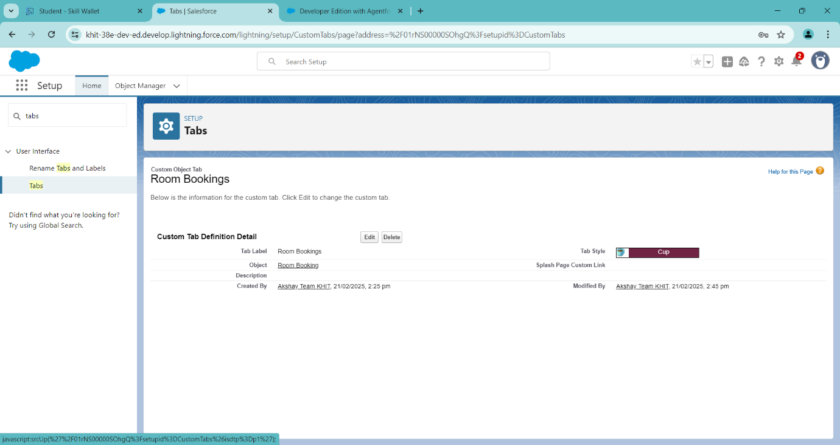

**3.3.4. Creating a Tab for Remaining Objects**

Create the Tabs for the remaining Custom Objects like Payments, Food Selections, Feedback Objects.

* 1. **The Lightning App**

A Lightning App is a scalable and modular framework built using Lightning AI. It enables developers to design, deploy, and manage AI/ML applications with minimal code while ensuring high performance and scalability.

* + 1. **Creating a Lightning App**
       1. Go to setup page > search “app manager” in quick find > select “app manager” > click on New lightning App.
       2. Fill the app name in app details and branding > Next > (App option page) keep it as default > Next > (Utility Items) keep it as default > Next.
       3. To Add Navigation Items: Ctrl and Select the items (Total Rooms, Customers1, Room Booking, Payments1, Food selection, Feedbacks, Reports and Dashboards) from the search bar and move it using the arrow button > Next.
       4. To Add User Profiles:
       5. Search profiles (System administrator) in the search bar > click on the arrow button > save & finish.

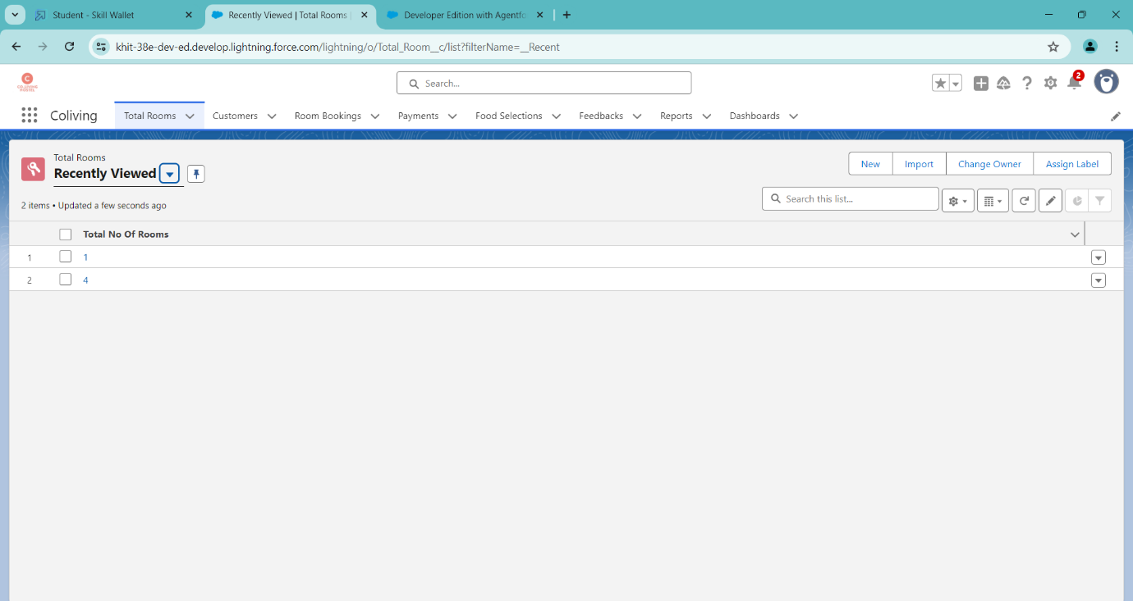

* 1. **Fields & Relationships**

Fields in Salesforce define the type of data that can be stored within an object. They help organize and structure information, ensuring that the correct data is captured for each record. Salesforce provides **Standard Fields** (predefined fields such as Name, Created Date, and Owner) and **Custom Fields** (user-defined fields tailored to specific business needs). Custom fields allow businesses to store relevant information that enhances their CRM’s functionality.

* + 1. **Creating Fields for the Customer1 Object**

1. Go to setup > click on Object Manager > type object name(Customer1) in search bar > click on the object.
2. Now click on “Fields & Relationships” > New
3. Select Data Type as a “Phone”
4. Click on next > Fill the blocks as following:
   * 1. Field Label: Phone no
     2. Field Name : gets auto generated
     3. Click on Next > Next > Save and next.

**To create another fields in an object:**

1. Go to setup > click on Object Manager > type object name (Customer1) in search bar > click on the object.
2. Now click on “Fields & Relationships” > New
3. Select Data type as a “Email” and Click on Next
4. Fill the Above as following:

* Field Label: Email
* Field Name :It’s  gets auto generated
* Click on Next > Next > Save and new.

**To create another fields in an object:**

1. Go to setup > click on Object Manager > type object name (Customer1)in search bar > click on the object.
2. Now click on “Fields & Relationships” > New
3. Select Data type as a “Text Area” and Click on Next
4. Fill the Above as following:

* Field Label: Permanent Address
* Field Name : It’s gets auto generated
* Click on Next > Next > Save and new.

**To create another fields in an object:**

1. Go to setup > click on Object Manager > type object name(Customer1) in search bar > click on the object.
2. Now click on “Fields & Relationships” > New
3. Select Data type as a “Picklist” and Click on Next
4. Fill the Above as following:

* Field Label: Current Status
* Value - Select enter values with each value separated by a new line

1. Student
2. Employee
3. Others
4. Select required
5. Field Name :It’s gets auto generated
6. Click on Next > Next > Save and new.

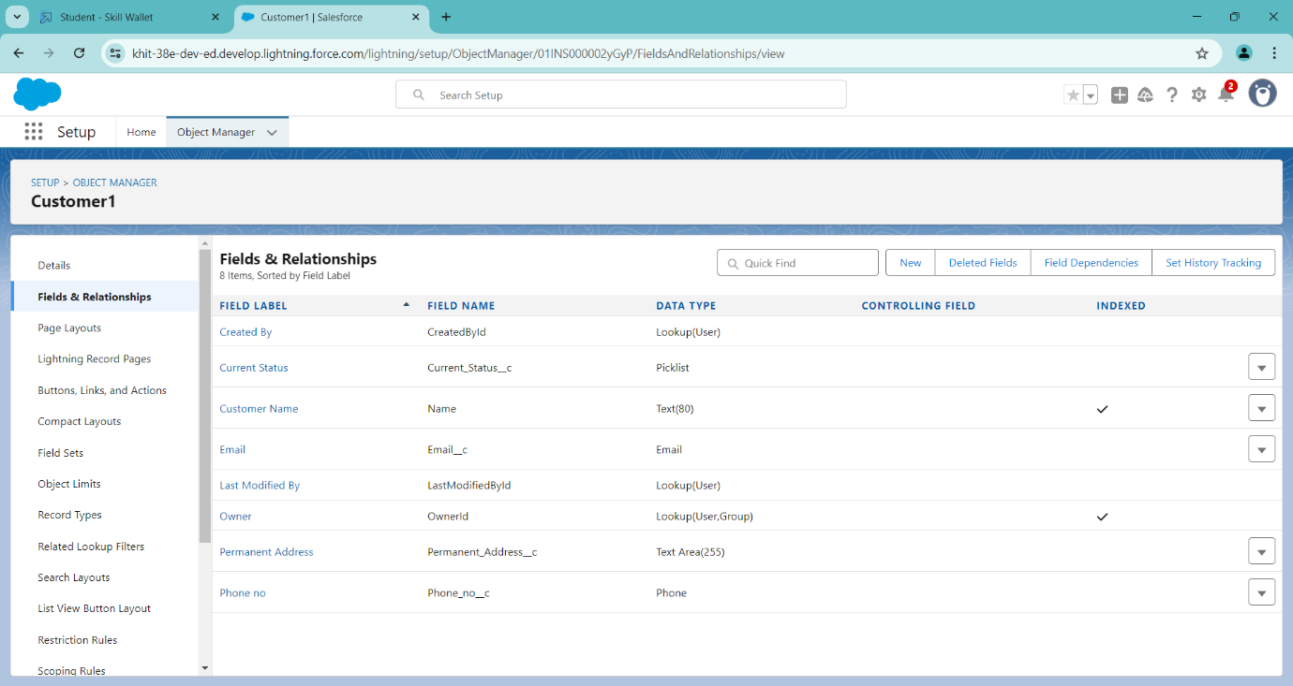

* + 1. **Creating Fields & Relationship for Room Booking Object**

Go to setup > click on Object Manager > type name(Room Booking) in the search bar > click on the object.

Now click on “Fields & Relationships” > New

Select Data Type as a “Picklist”

Click on Next

Fill the blocks as following:

* 1. Field Label: Room Sharing

Value - Select enter values with each value separated by a new line

Single sharing

Double sharing

Triple sharing

Select required

Click on Next > Next > Save and new.sssss

**To Create a Fields & Relationship to an Room Booking Object**

To create fields & relationship to an object:

1. Go to setup > click on Object Manager > type object name(Room Booking) in the search bar > click on the object.
2. Now click on “Fields & Relationships” > New
3. Select Data Type as a “Master-detail Relationship”
4. Click on Next
5. Click on the Related to drop down and Select the “Customer1” object and click on Next
6. Fill the Above as following:
7. Change the Field Label: Name
8. Field Name: It’s gets auto generated
9. **To create fields in an object:**
10. Go to setup > click on Object Manager > type object name(Room Booking) in the search bar > click on the object.
11. Now click on “Fields & Relationships” > New
12. Select Data Type as a “Checkbox”
13. Click on Next
14. Fill the Above as following:

* Field Label: AC-3000
* Field Name :It’s gets auto generated
* Click on Next > Next > Save and new.

1. **To create fields in an object:**
2. Go to setup > click on Object Manager > type object name(Room Booking) in the search bar > click on the object.
3. Now click on “Fields & Relationships” > New
4. Select Data Type as a “Checkbox”
5. Click on Next
6. Fill the Above as following:

* Field Label: Advance Payment for 1 Month
* Field Name :It’s gets auto generated
* Click on Next > Next > Save and new

1. **To create fields in an object:**
2. Go to setup > click on Object Manager > type object name(Room Booking) in the search bar > click on the object.
3. Now click on “Fields & Relationships” > New
4. Select Data Type as a “Currency”
5. Click on Next
6. Fill the Above as following:

* Field Label: Amount
* Length: (18,0)
* Field Name :It’s gets auto generated
* Click on Next > Next > Save and new

1. **To Create a Fields & Relationship to an Object**
2. Go to setup > click on Object Manager > type object name(Room Booking) in the search bar > click on the object.
3. Now click on “Fields & Relationships” > New
4. Select Data Type as a “Master-detail Relationship”
5. Click on Next
6. Click on the Related to drop down and Select the “Total Rooms” object and click on Next.
7. Fill the Above as following:

* Change the Field Label: Total No Of Rooms
* Field Name :It’s gets auto generated
* Click on Next > Next > Save and new.

1. **To Create a Rollup Summary Field in “Total Room Object”**
2. After Creating the Master- Detail Relationship Than Only you can create the Rollup Summary
3. Go to setup > click on Object Manager > type object name(Total Rooms) in the search bar > click on the object.
4. Now click on “Fields & Relationships” now New
5. Select Data type as a “Roll-up Summary” and Click on Next

* Fill the Above as following:
* Field Label: Rooms Booked
* Field Name :It’s gets auto generated
* Click on Next

1. Select the Room Bookings in the Summarized Object
2. Select the count Radio button in the select Roll-up Type
3. Click on Next > Next > Save and new
4. **To create fields in an object:**
5. Go to setup > click on Object Manager > type object name(Rooms Booking) in the search bar > click on the object.
6. Now click on “Fields & Relationships” > New
7. Select Data type as a “Formula” and Click on Next
8. Fill the Above as following:
9. Field Label: Rooms Available
10. Field Name : It’s gets auto generated
11. Select the Formula Return Type as “Number”
12. Select the Decimal places as “0” and Click on Next
13. Click on the Advanced Formula and Enter the value in formula box “

30 - ” and Click on insert field than you will find a pop window under the Room Booking

10. select the Total No Of Rooms in the second Column and select the Room Booked in the third column and click on insert “ 30  -  Total_No_Of_Rooms__r.Rooms_Booked__c ” and Check Syntax

11. Click on Next > Next > Save and new.

**7) To create fields in an object:**

1. Go to setup > click on Object Manager > type object name(Room Booking) in the search bar > click on the object.
2. Now click on “Fields & Relationships” > New
3. Select Data Type as a “Checkbox”
4. Click on Next
5. Fill the Above as following:

* Field Label: Check in
* Field Name :It’s gets auto generated
* Click on Next > Next > Save and new
  1. **To create fields in an object:**

1. Go to setup > click on Object Manager > type object name(Room Booking) in the search bar > click on the object.
2. Now click on “Fields & Relationships” > New
3. Select Data Type as a “Checkbox”
4. Click on Next
5. Fill the Above as following:

* Field Label: Check Out
* Field Name :It’s gets auto generated
* Click on Next > Next > Save and new

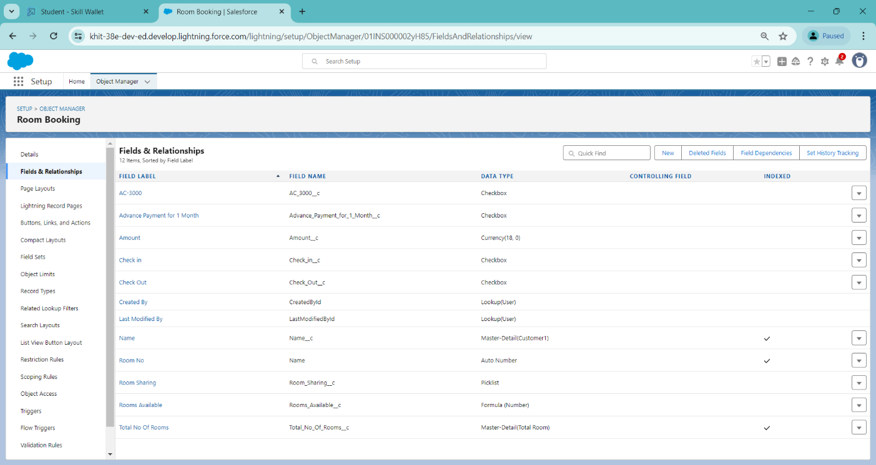

**3.5.3. Creation Of Fields & Relationship For Payment1 Object**

**1. To create fields & relationship to an object:**

1. Go to setup > click on Object Manager > type object name(Payment1) in the search bar > click on the object.
2. Now click on “Fields & Relationships” > New
3. Select Data Type as a “Master-detail Relationship”
4. Click on Next
5. Click on the Related to drop down and Select the Customer1 object and click on Next
6. Fill the Above as following:
7. Change the Field Label: Name
8. Field Name :It’s gets auto generated
9. Click on Next > Next > Save and new.

**2. To create another fields & relationship to an object:**

1. Go to setup > click on Object Manager > type object name(Payment1) in the search bar > click on the object.
2. Now click on “Fields & Relationships” > New
3. Select Data Type as a “Lookup Relationship”
4. Click on Next
5. Click on the Related to drop down and Select the Room Booking object and click on Next
6. Fill the Above as following:
7. Change the Field Label: Room Booking
8. Field Name: It’s gets auto generated
9. Click on Next > Next > Save and new.

**3. Creation of another fields for the Payment1 object**

To create fields in an object:

1. Go to setup > click on Object Manager > type object name(Payment1) in the search bar > click on the object.
2. Now click on “Fields & Relationships” > New
3. Select Data Type as a “Picklist”
4. Fill the Above as following:
5. Field Label: Payment Mode
6. Value - Select enter values with each value separated by a line
7. Cash, Check, Credit card, Debit card, UPI, Phonepe, Gpay, Paytm
8. Select required Click on Next > Next > Save and new.
9. Click on the Check syntax: No syntax errors in merge fields
10. Click on Next > Next > Save and new.

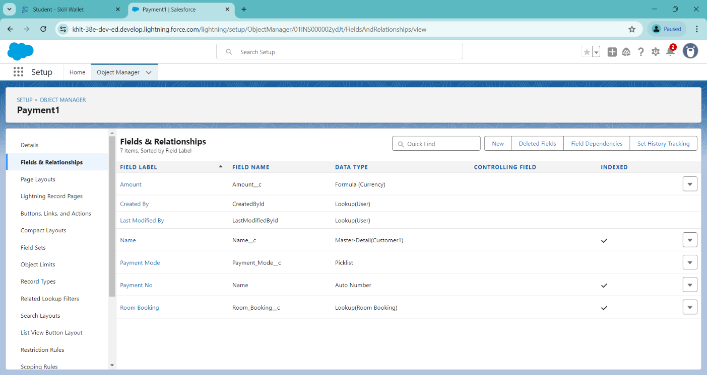

**3.5.4. Creation Of Fields For The Food Selection Object**

**1. To create fields & relationship to an object:**

1. Go to setup > click on Object Manager > type object name(Room Booking) in the search bar > click on the object.
2. Now click on “Fields & Relationships” > New
3. Select Data Type as a “Master-detail Relationship”
4. Click on Next
5. Click on the Related to drop down and Select the Customer1 object and click on Next
6. Fill the Above as following:

* Change the Field Label: Name
* Field Name :It’s gets auto generated
* Click on Next > Next > Save and new.

**Create a picklist value set:**

1. First click on gear icon and click on setup
2. Click on home tab in the Quick find box search for the “ Picklist value sets ”
3. Click on the Picklist value set and click on new
4. Enter the Label name and API name automatically Generate
5. Enter the values with each value separated by a new line

* Sunday
* Monday
* Tuesday
* Wednesday
* Thursday
* Friday
* Saturday

1. Check the Use first value as default value and Click on save.

**2. Create a picklist Field for Food selection object**

1. Go to setup > click on Object Manager > type object name(Food Selection) in the search bar > click on the object.
2. Now click on “Fields & Relationships” > New
3. Select Data Type as a “Picklist”
4. Fill the Above as following:

* Field Label: Breakfast
* Under Value - Select the Use global picklist value set
* Under the drop down select the Custom Picklist Values

1. Select required
2. Click on Next > Next > Save and new.

**3. Create a another picklist Field for Food selection object**

To create fields in an object :

1. Go to setup > click on Object Manager > type object name(Food Selection) in the search bar > click on the object.
2. Now click on “Fields & Relationships” > New
3. Select Data Type as a “Picklist”
4. Fill the Above as following:

* Field Label: Select Breakfast
* Under Value - Enter values, with each value separated by a new line

1. Idli
2. Bonda
3. Dosa
4. Upma
5. Vada
6. Puri
7. Chapati

* Select Checkbox Use First value as default Value
* Click on Next > Next > Save and new.

**Create a Field Dependency on Breakfast and Select Breakfast Fields in Food Selection Object.**

1. Go to setup > click on Object Manager > type object name(Food Selection) in the search bar > click on the object.
2. Now Click on fields & relationships and Click on Field Dependencies
3. Now Click on New Option
4. Under Controlling Field: Breakfast, Dependent Field: Select Breakfast and Click on Continue
5. Under the Sunday Ctrl and select the Picklist values Idli Dosa,Puri and Click on Include Values in such a way that do for the remaining days and click on save.

**4. To create fields in an object:**

1. Go to setup > click on Object Manager > type object name(Food Selection) in the search bar > click on the object.
2. Now click on “Fields & Relationships” > New
3. Select Data Type as a “Picklist”
4. Fill the Above as following:

* Field Label: Lunch
* Under Value - Select the Use global picklist value set
* Under the drop down select the Custom Picklist Values
* Select required
* Click on Next > Next > Save and new.

**5. To create fields in an object:**

1. Go to setup > click on Object Manager > type object name(Food Selection) in the search bar > click on the object.
2. Now click on “Fields & Relationships” > New
3. Select Data Type as a “Picklist”
4. Fill the Above as following:

* Field Label: Select Lunch
* Under Value - Enter values, with each value separated by a new line

1. Meals
2. Chicken biryani
3. Veg biryani
4. Veg fried rice
5. Egg fried rice
6. Chicken fried rice
7. Curd rice
8. Tomato rice
9. Egg noodles
10. Chicken Noodles
11. Bhagara rice

* Select Checkbox Use First value as default Value
* Click on Next > Next > Save and new.

**To create a Field dependencies for Lunch and Select Lunch.**

1. Go to setup > click on Object Manager > type object name(Food Selection) in the search bar > click on the object.
2. Now Click on fields & relationships and Click on Field Dependencies
3. Now Click on New Option
4. Under Controlling Field:Lunch, Dependent Field: Select Lunch and Click on Continue
5. Under the Sunday Ctrl and select the Picklist values Chicken biryani, Egg fried rice, curd rice and Click on Include Values in such a way that do for the remaining days and click on save.

**6. To create fields in an object:**

1. Go to setup > click on Object Manager > type object name(Food Selection) in the search bar > click on the object.
2. Now click on “Fields & Relationships” > New
3. Select Data Type as a “Picklist”
4. Fill the Above as following:

* Field Label: Dinner
* Under Value - Select the Use global picklist value set
* Under the drop down select the Custom Picklist Values
* Select required
* Click on Next > Next > Save and new.

**7. To create fields in an object:**

1. Go to setup > click on Object Manager > type object name(Food Selection) in the search bar > click on the object.
2. Now click on “Fields & Relationships” > New
3. Select Data Type as a “Picklist”
4. Fill the Above as following:

* Field Label: Select Dinner
* Under Value - Enter values, with each value separated by a new line
  1. Meals
  2. Chicken biryani
  3. Veg biryani
  4. Veg fried rice
  5. Egg fried rice
  6. Chicken fried rice
  7. Curd rice
  8. Tomato rice
  9. Egg noodles
  10. Chicken Noodles
  11. Bhagara rice

1. Select Checkbox Use First value as default Value
2. Click on Next > Next > Save and new.

**To create a Field dependencies for Dinner and Select Dinner.**

* 1. Go to setup > click on Object Manager > type object name(Food Selection) in the search bar > click on the object.
  2. Now Click on fields & relationships and Click on Field Dependencies
  3. Now Click on New Option
  4. Under Controlling Field: Dinner, Dependent Field: Select Dinner and Click on Continue
  5. Under the Sunday Ctrl and select the Picklist values Chicken biryani, curd rice, Chicken noodles and Click on Include Values in such a way that do for the remaining days and click on save.

1. Change the Field Label: Name
2. Field Name :It’s gets auto generated
3. Click on Next > Next > Save and new.

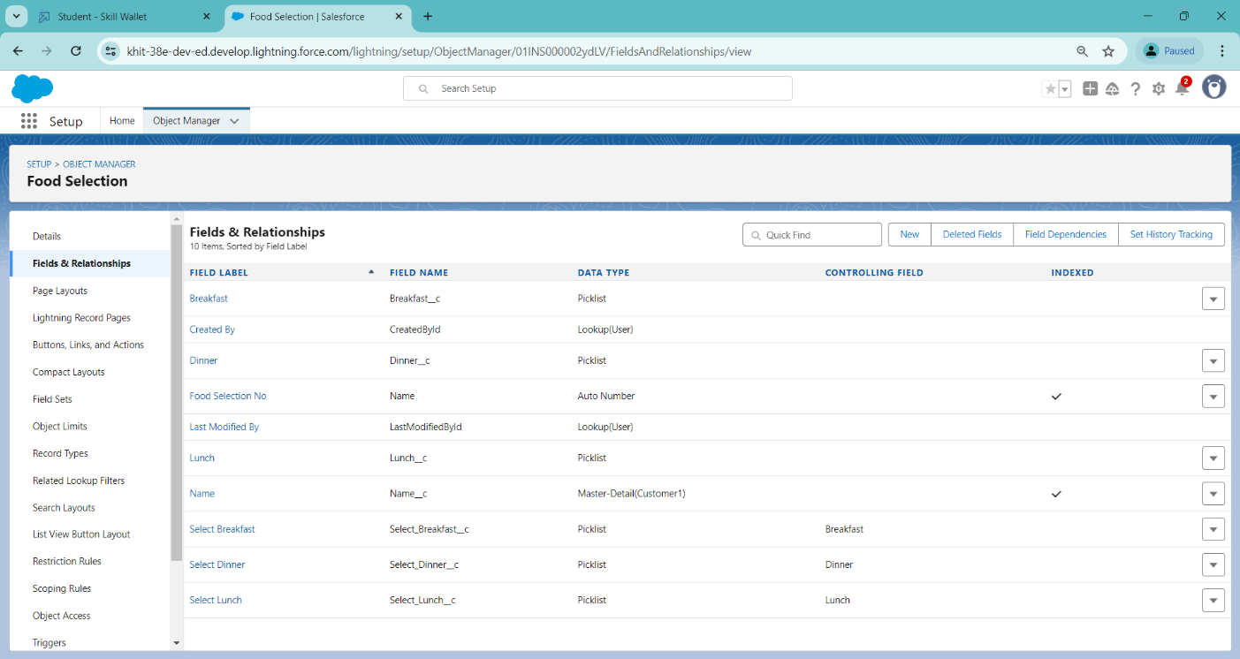

### **3.5.5. Creation Of Fields For The Feedback Object**

**1. To Create fields & relationship to an object:**

1. Go to setup > click on Object Manager > type object name(Feedback) in search bar > click on the object.
2. Now click on “Fields & Relationships” > New
3. Select Data Type as a “Lookup Relationship”

**2. To create Another fields in an Same object:**1. Go to setup > click on Object Manager > type object name(Feedback) in search bar > click on the object.

1. Now click on “Fields & Relationships” > New
2. Select Data Type as a “Picklist”, Click on Next
3. Fill the Above as following:
4. Field Label: Roomcleaning
5. Field Name :It’s gets auto generated
6. Under Values select Enter values, with each value separated by a new line

* Good
* Satisfaction
* Bad

1. Click on Next > Next > Save and new.

**3. To create a Another Fields in an Same Object**

1. Go to setup > click on Object Manager > type object name(Feedback) in search bar > click on the object.
2. Now click on “Fields & Relationships” > New
3. Select Data Type as a “Picklist”
4. Click on Next
5. Fill the Above as following:

* Field Label: Internet
* Field Name :It’s gets auto generated
* Under Values select Enter values, with each value separated by a new line
* Good
* Satisfaction
* Bad

6.Click on Next > Next > Save and new.

**4. To create a Another Fields in an Same Object**

1. Go to setup > click on Object Manager > type object name(Feedback) in search bar > click on the object.
2. Now click on “Fields & Relationships” > New
3. Select Data Type as a “Picklist”
4. Click on Next
5. Fill the Above as following:

* Field Label: Food
* Field Name :It’s gets auto generated
* Under Values select Enter values, with each value separated by a new line
* Good,Satisfaction ,Bad

6.Click on Next > Next > Save and new.

**5. To create a Another Fields in an Same Object**

1. Go to setup > click on Object Manager > type object name(Feedback) in search bar > click on the object.
2. Now click on “Fields & Relationships” > New
3. Select Data Type as a “Text area”
4. Click on Next
5. Fill the Above as following:

* Field Label: Suggestion
* Field Name :It’s gets auto generated
* Click on Next > Next > Save and new.

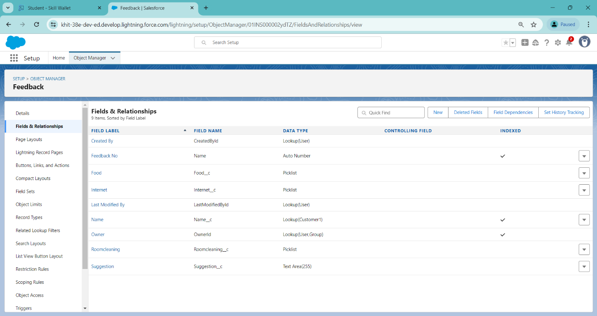

**3.5.6. Creation Of Fields For The Total Rooms Object**

**1. To create fields in an object:**

1. Go to setup > click on Object Manager > type object name(Total Rooms) in search bar > click on the object.
2. Now click on “Fields & Relationships” > New
3. Select Data type as a “Formula” and Click on Next
4. Fill the Above as following:
5. Field Label: Rooms Available
6. Field Name : It’s gets auto generated
7. Select the Formula Return Type as “Number”
8. Select the Decimal places as “0” and Click on Next
9. Click on the Advanced Formula “ 30 -  Rooms_Booked__c ” and Check Syntax
10. Click on Next > Next > Save and new.

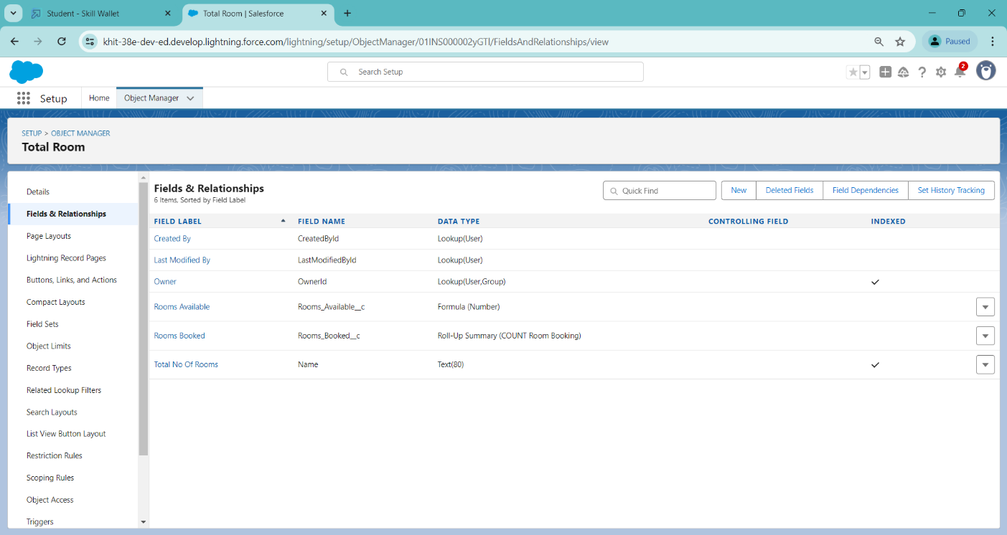

* 1. **Validation Rule**

Validation rules are applied when a user tries to save a record and are used to check if the data meets specified criteria. If the criteria are not met, the validation rule triggers an error message and prevents the user from saving the record until the issues are resolved.

* + 1. **To Create A Validation Rule To An Room Booking Object**
  1. Go to setup > click on Object Manager > type object name(Room Booking) in the search bar > click on the object.
  2. Now click on “Validation rule” at top > New.
  3. Enter Rule name “checkbox field” and make the validation should be Active.
  4. Enter the formula in the formula Box “Advance_payment_for_1month__c  = false” and check for syntax error.
  5. Enter the error message “Checkbox should be checked”
  6. Select error location as field (Advance payment for 1month)
  7. Click on save.

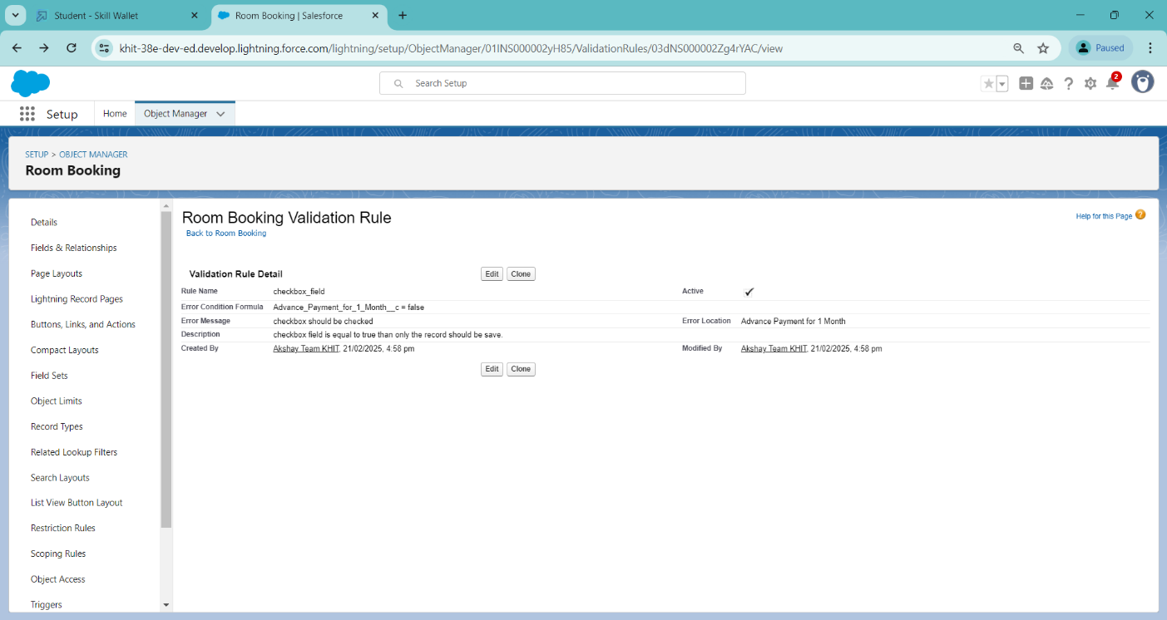 **3.6.2. Creating an another Validation Rule To An Room Booking Object**

1. Go to setup > click on Object Manager > type object name(Room Booking) in the search bar > click on the object.
2. Now click on “Validation rule” at top > New.
3. Enter Rule name “check in rule” and make the validation should be Active.
4. Enter the formula in the formula Box “ Check_in__c = False ” and check for syntax error.
5. Enter the error message “Check box should be checked”
6. Select error location as field(Check in).Click on Save..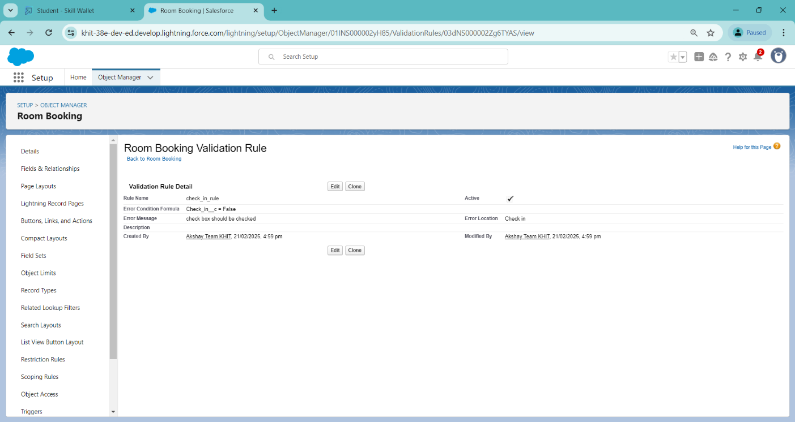
   1. **Profile**

A profile is a group/collection of settings and permissions that define what a user can do in salesforce. Profile controls “Object permissions, Field permissions, User permissions, Tab settings, App settings, Apex class access, Visualforce page access, Page layouts, Record Types, Login hours & Login IP ranges. You can define profiles by the user's job function. For example System Administrator, Developer, Sales Representative.

**Types of profiles in salesforce**

* 1. Standard profiles
  2. Custom Profiles
     1. **To Create a Custom User Profile**
     2. To create a new profile -> Go to setup > type profiles in quick find box > click on profiles > clone the desired profile (Standard User)
     3. Enter profile name (Custom User) > Save.
     4. While still on the profile page, then click Edit.
     5. Scroll down to Custom Object Permissions and Give All access permissions for Customers, Feedbacks, Food selections, Payments, Room Bookings and Total Rooms.
     6. Scroll down and Click on Save.

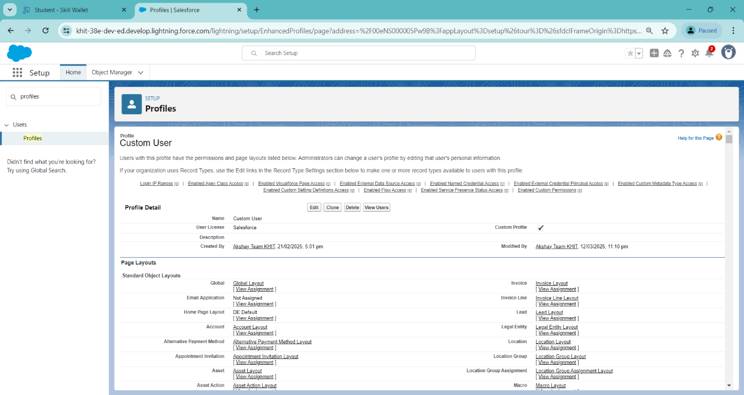

* + 1. **To Create Custom Platform User1**

**To create a new profile:**

* + - 1. Go to setup > type profiles in quick find box > click on profiles > clone the desired profile (Standard platform User)
      2. Enter profile name (Custom platform User1) > Save.
      3. While still on the profile page, then click Edit.
      4. Scroll down to Custom Object Permissions and Give only Read access permissions for Customers, Feedbacks, Food selections, Payments, Room Bookings and Total Rooms.
      5. Scroll down and Click on Save.

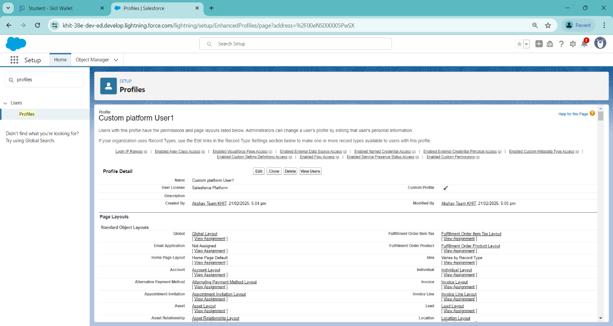

* + 1. **To Create Custom Platform User2**

**To create a new profile:**

* + - * 1. Go to setup > type profiles in quick find box > click on profiles > clone the desired profile (Standard platform User)
        2. Enter profile name (Custom platform User2) > Save.
        3. While still on the profile page, then click Edit.
        4. Scroll down to Custom Object Permissions and Give Create, Read, Edit and Delete access permissions for Customers, Feedbacks, Food selections, Payments and Room Bookings. And Read Access permission for Total Rooms Object.
        5. Scroll down and Click on Save.

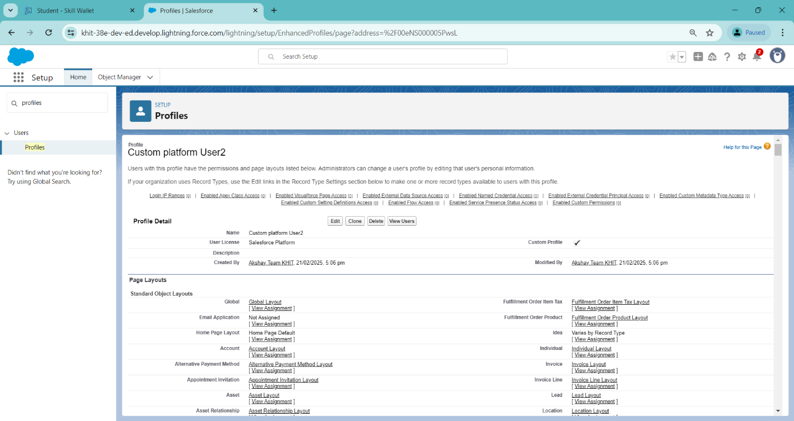

* 1. **Roles**

A role in Salesforce defines a user's visibility access at the record level. Roles may be used to specify the types of access that people in your Salesforce organization can have to data. Simply put, it describes what a user could see within the Salesforce organization.

**3.8.1. Creating a Marketing Role**

Go to quick find > Search for Roles > click on set up roles.

Click on Expand All and click on add role under CEO role.

Give Label as “Marketing” and Role name gets auto populated.

Then click on Save.

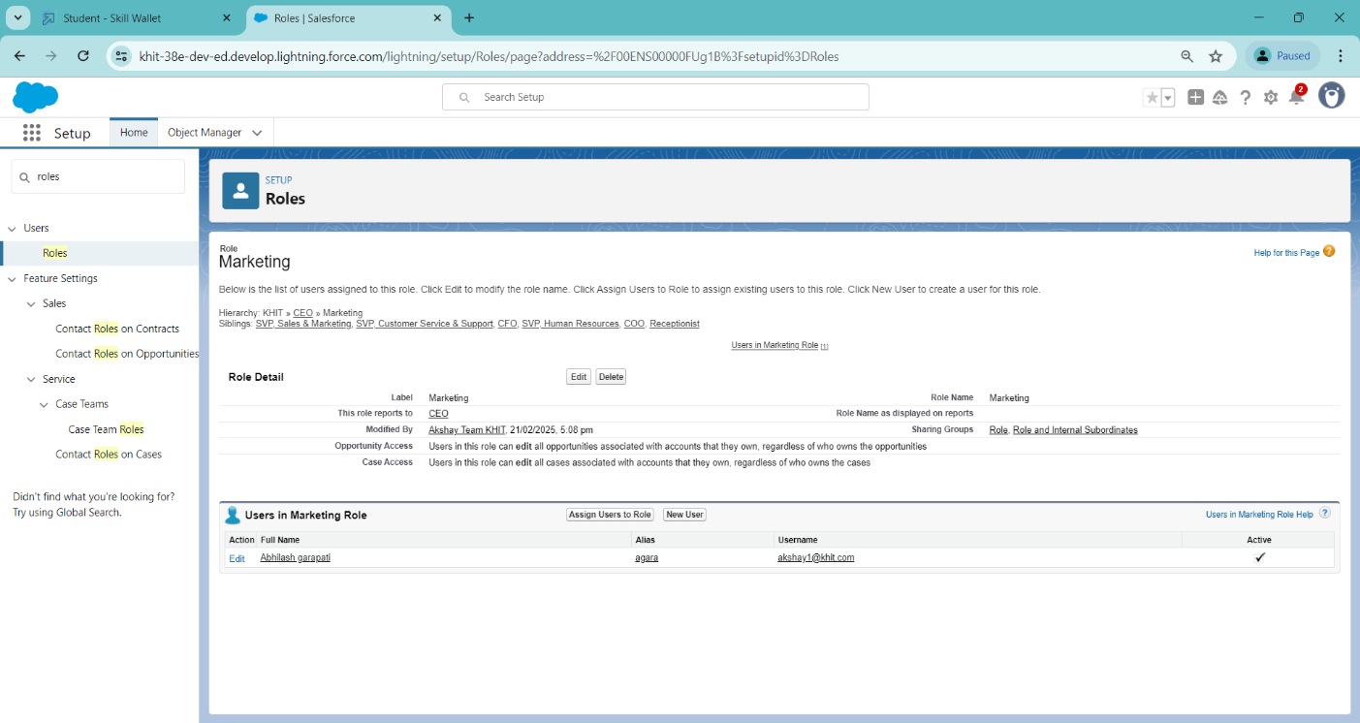

**3.8.2. Creating a Receptionist Role**

1. Go to quick find > Search for Roles > click on set up roles.
2. Click on Expand All and click on add role under CEO role.
3. Give Label as “Receptionist” and Role name gets auto populated.
4. Then Click on Save.

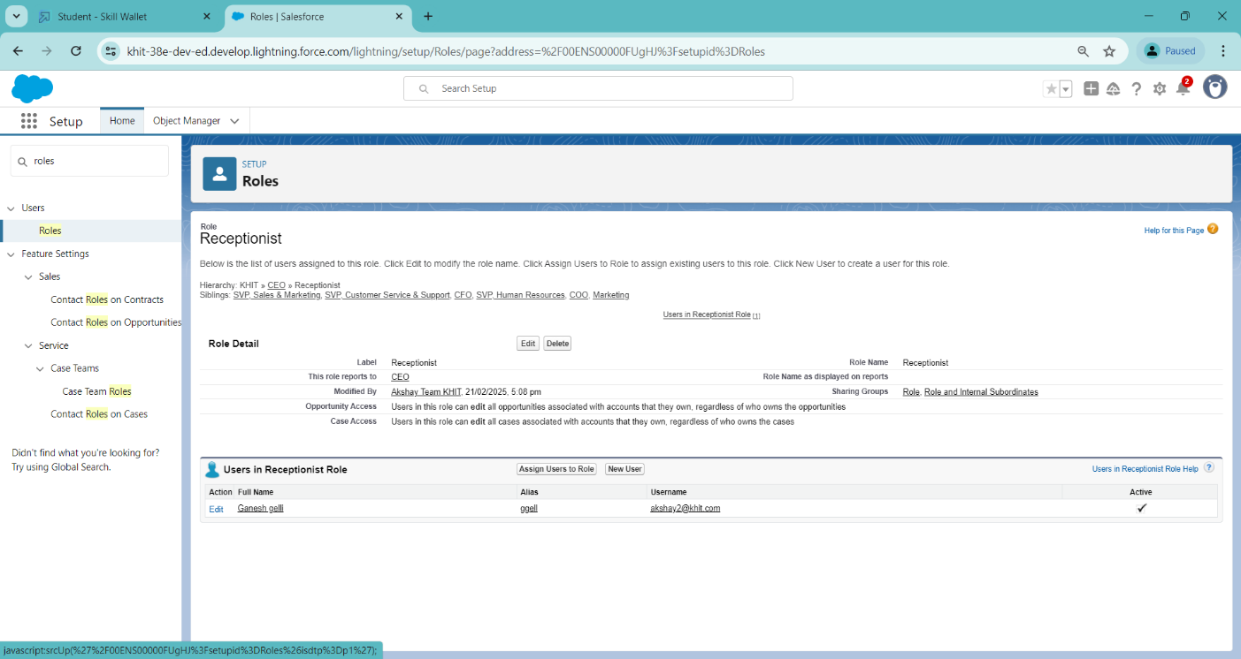

### **Users**

A user is anyone who logs in to Salesforce. Users are employees at your company, such as sales reps, managers, and IT specialists, who need access to the company's records. Every user in Salesforce has a user account. The user account identifies the user, and the user account settings determine what features and records the user can access.

* + 1. **Creation of an User**
  1. Go to setup > type users in quick find box > select users > click New user.
  2. Fill in the fields
  + **First Name :** sandeep
  + **Last Name :** gujja
  + **Alias :** Give a Alias Name
  + **Email id :** Give your Personal Email id
  + **Username :** Username should be in this form: text@text.com
  + **Nick Name :** Give a Nickname
  + **Role   :** CEO
  + **User licence :** Salesforce
  + **Profiles   :** Custom user
  1. Save

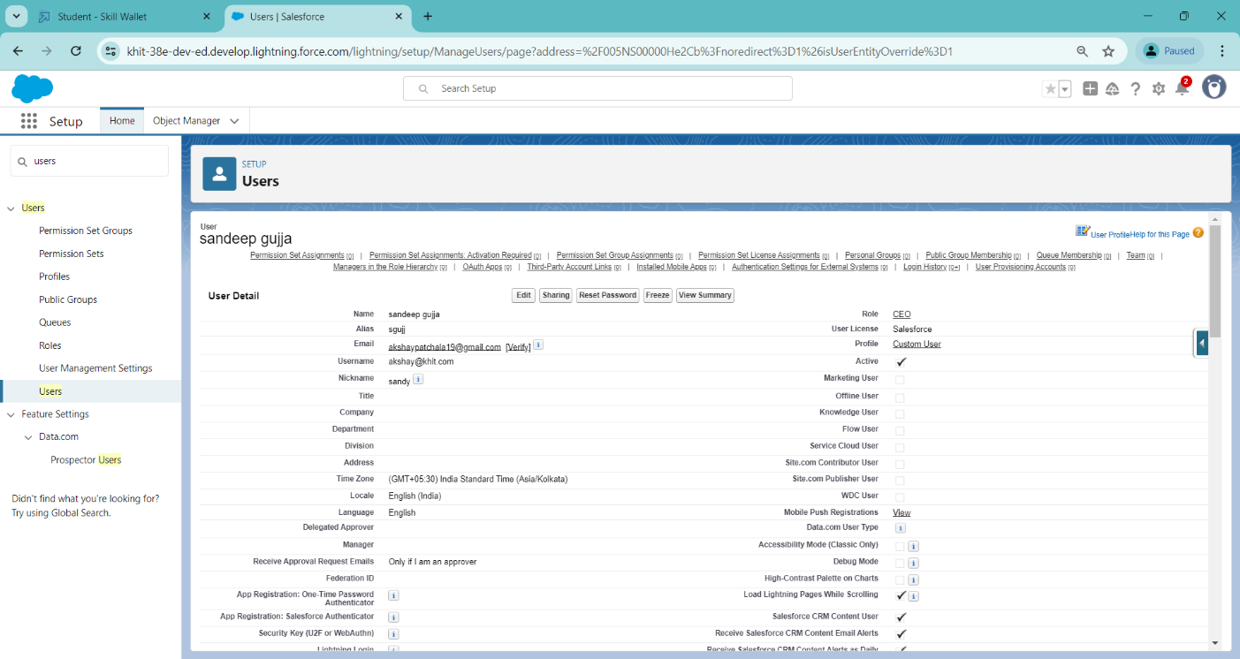

* + 1. **Create Another Two Users**

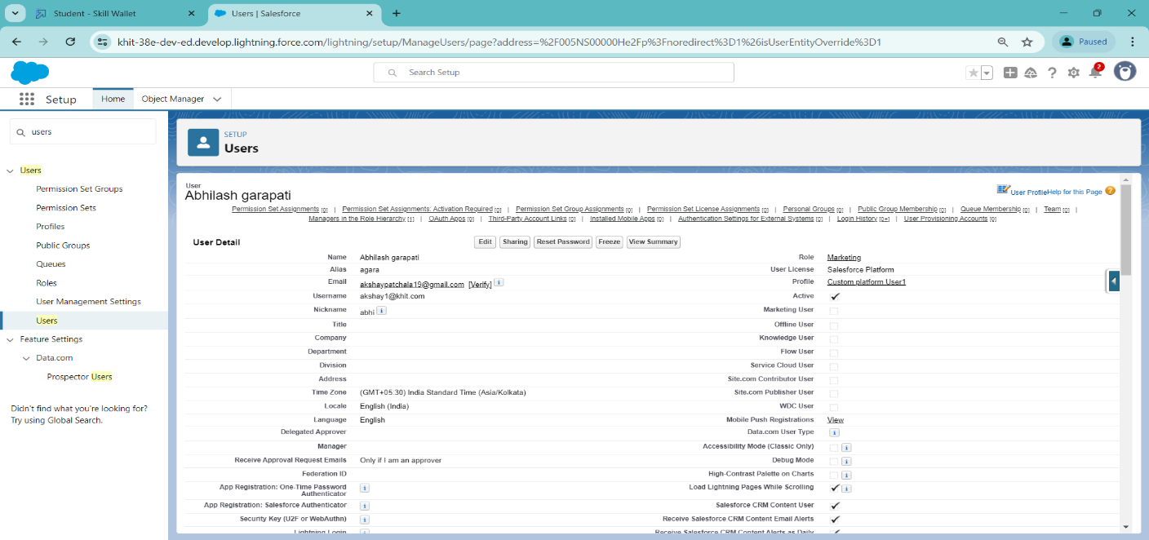

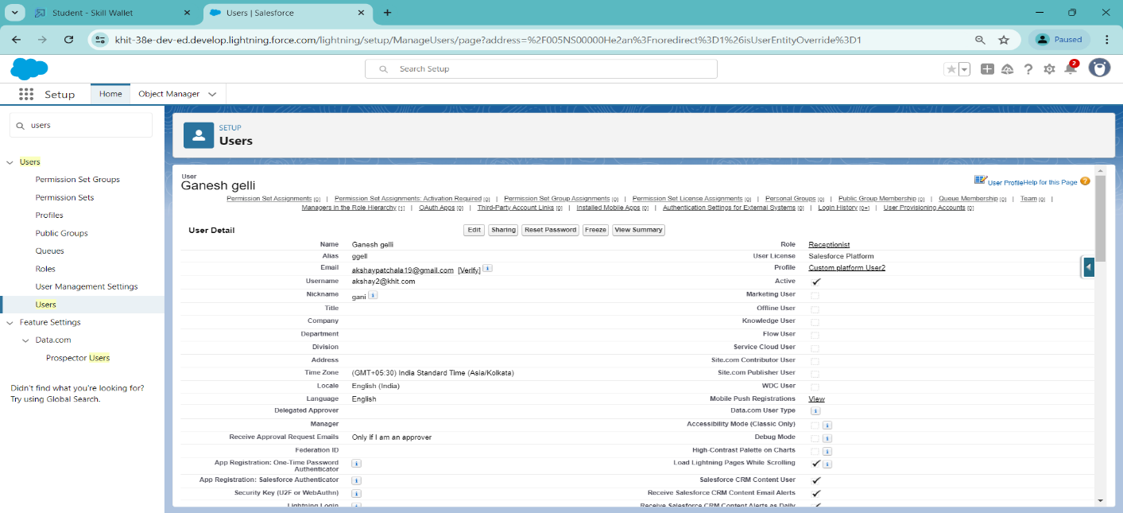

* 1. **User Adoption**
     1. **Creating a Record (Customers)**
     2. Click on App Launcher on the left side of the screen.
     3. Search Home Feels & click on it.
     4. Click on the Customers Tab.
     5. Click new and fill details & Save

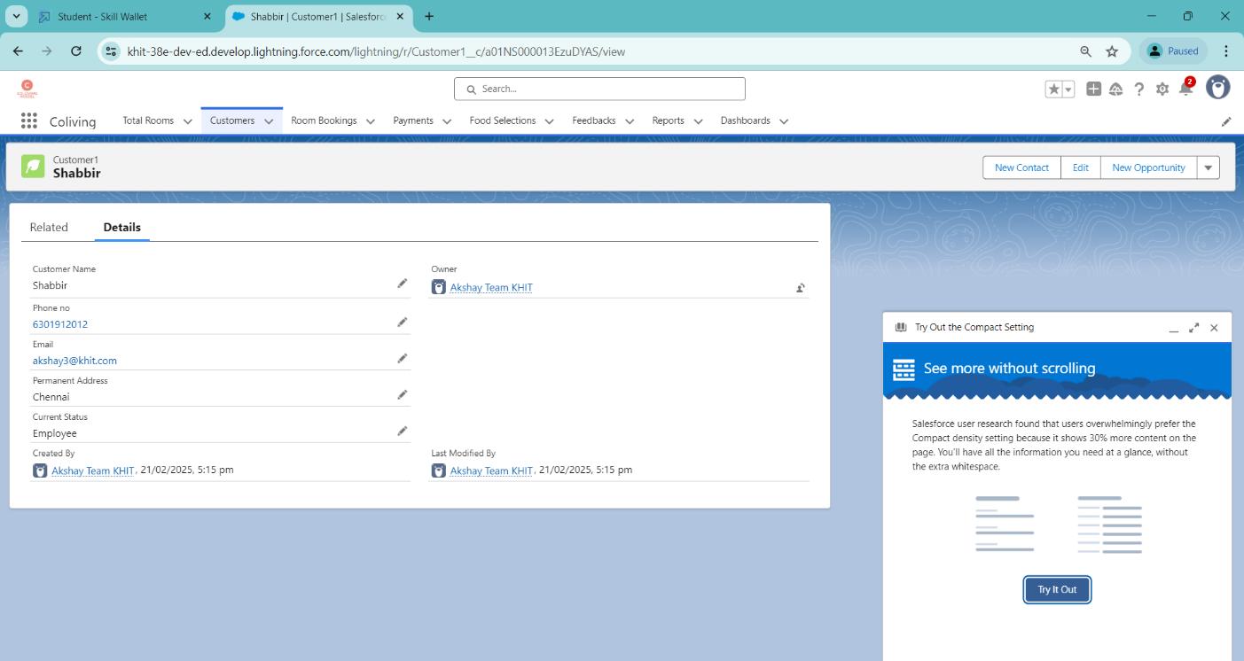

* + 1. **Viewing a Record (Customers)**
       1. Click on App Launcher on the left side of the screen.
       2. Search Home Feels & click on it.
       3. Click on Customer Tab.
       4. Click on any record name. you can see the details of the Customer.

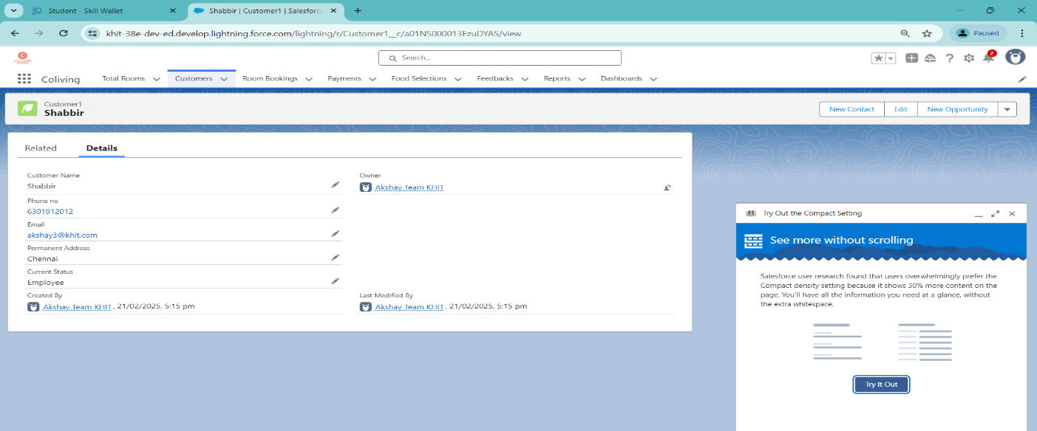

* + 1. **Deleting a Record (Customers)**

1. Click on App Launcher on the left side of the screen.
2. Search Home Feels & click on it.
3. Click on the Customers Tab.
4. Click on Arrow at right hand side on that Particular record.
5. Click delete and delete again.

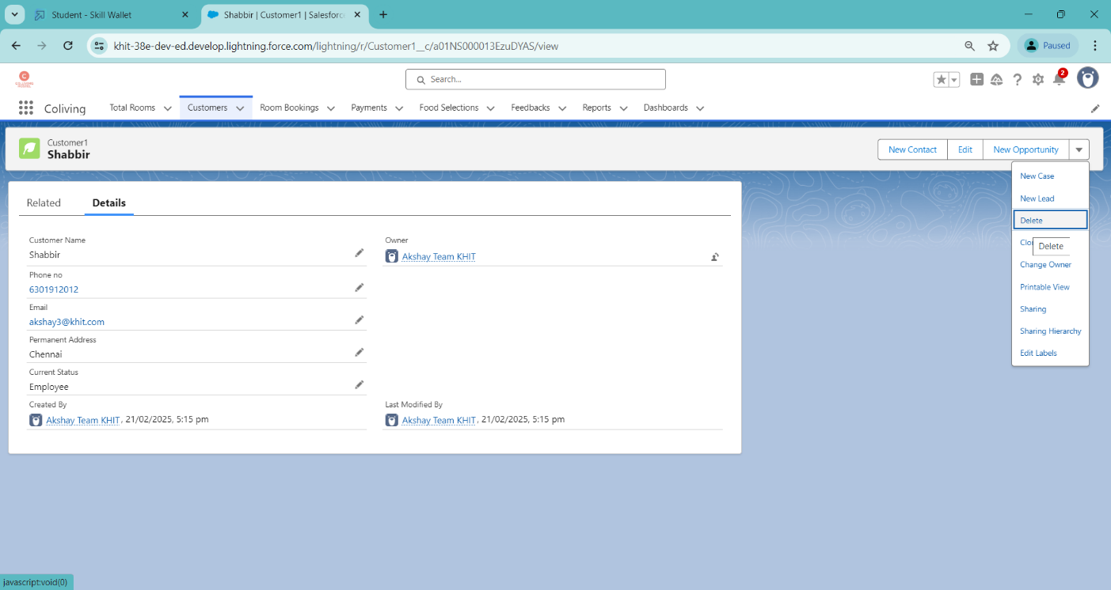

* 1. **Reports**

Reports give you access to your Salesforce data. You can examine your Salesforce data in almost infinite combinations, display it in easy-to-understand formats, and share the resulting insights with others. Before building, reading, and sharing reports, review these reporting basics.   
Types of Reports in Salesforce

1. Tabular
2. Summary
3. Matrix
4. Joined Reports
   * 1. **Creating a Report**
        + 1. Go to the app > click on the reports tab
          2. Click New Report.
          3. Select report type from category or from report type panel or from search panel “Customers with Room Bookings with Total Rooms ” > click on start report.
          4. Customize your report
          5. Add fields from left pane as shown below
          6. Save or run it.

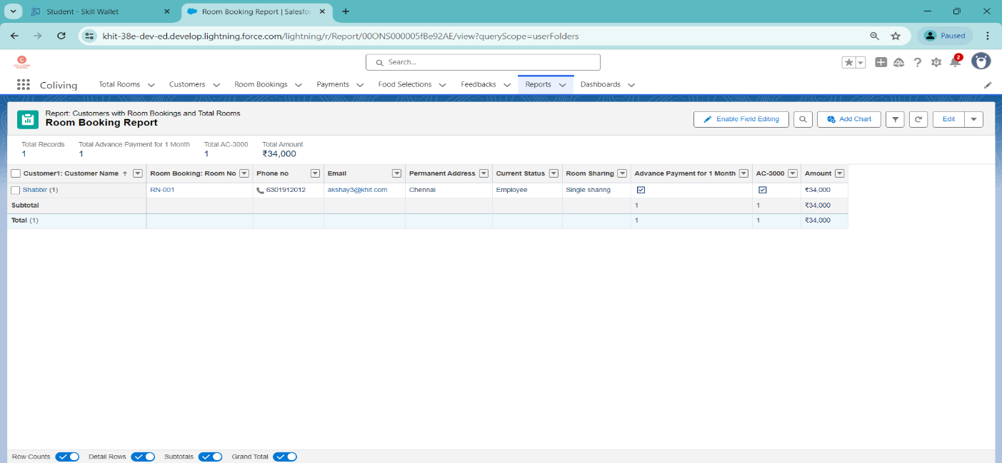

* + 1. **Creating another Report**

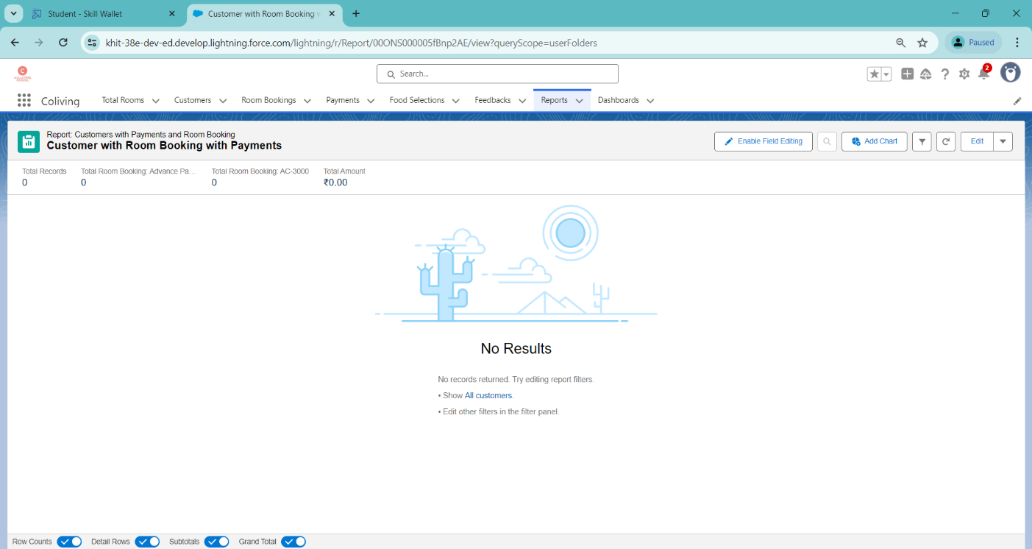

* 1. **Dashboards**

Dashboards help you visually understand changing business conditions so you can make decisions based on the real-time data you’ve gathered with reports. Use dashboards to help users identify trends, sort out quantities, and measure the impact of their activities. Before building, reading, and sharing dashboards, review these dashboard basics.

* + 1. **Creating a Dashboard**

Go to the app > click on the Dashboard tabs and click on new Dashboard

Give a Name and click on Create.

Select add component.

Select a Report Customer with Room Booking and click on select.

Click Add then click on Save and then click on Done.

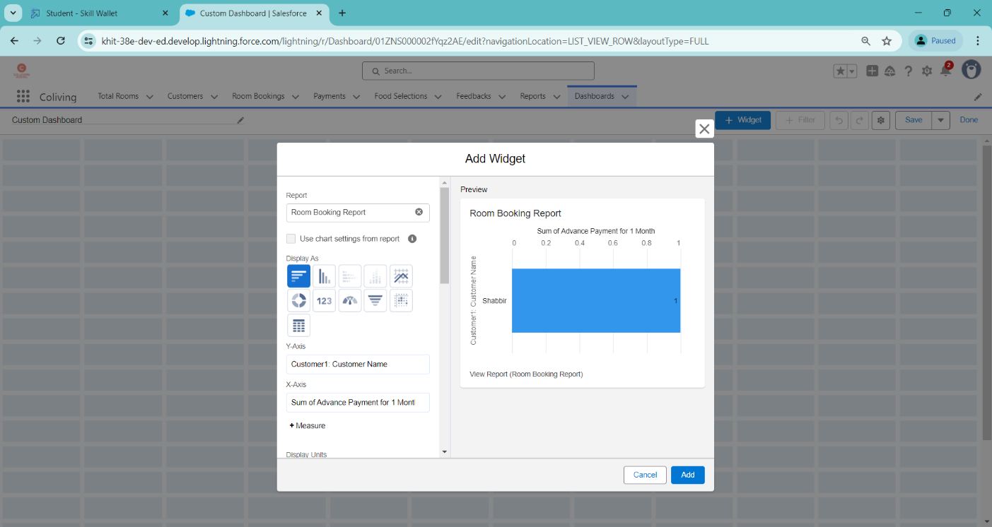

* + 1. **Creating another Dashboard**

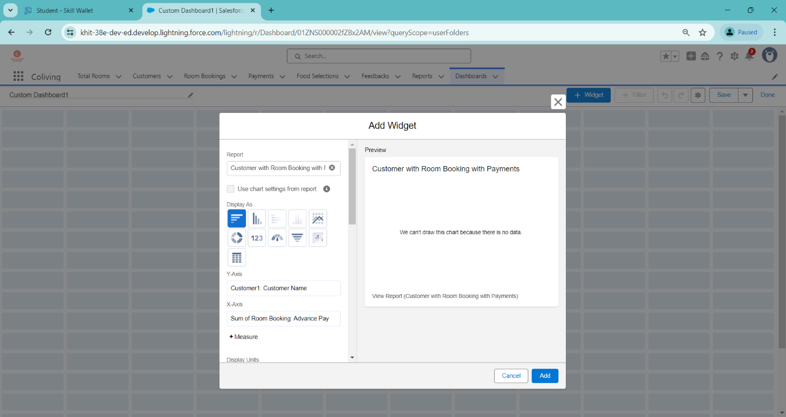

* 1. **Flows**

A flow is a powerful tool that allows you to automate business processes, collect and update data, and guide users through a series of screens or steps. Flows are built using a visual interface and can be created without any coding knowledge.

* + 1. **Creating a Flow**

Go to setup > type Flow in quick find box > Click on the Flow and Select the New Flow.

Select the Record-triggered flow and Click on Create.

Select the Object as a Room Booking in the Drop down list.

Select the Trigger Flow when: “A record is Created or Updated”.

Select the Optimize the flow for: “Actions and Related Records” and Click on Done.

Under the Record-triggered Flow Click on “+” Symbol and In the Drop down List select the “Decision Element”.

Enter the Details Label: Field should be Update, API name: Gets Automatically Generated.

Enter the Outcome Details

* Label: Single sharing
* Outcome API name: Gets Automatically Generated.
  + Resource: Select Record.Room sharing.

Operator: Select Equals.

Value: Select Single sharing.

Click on “Add Condition”

Resource: Select Record.AC-3000.

Operator: Select Equals.

Value: Select False.

Click on “+” Symbol In the Outcome Order.

Enter the Outcome Details

* Label: Double sharing
* Outcome API name: Gets Automatically Generated.
* Resource: Select Record.Room sharing.
* Operator: Select Equals.
* Value: Select Double sharing.

Click on “Add Condition”

* Resource: Select Record.AC-3000.
* Operator: Select Equals.
* Value: Select False.

Click on “+” Symbol In the Outcome Order.

Enter the Outcome Details

* Label: Triple sharing
* Outcome API name: Gets Automatically Generated.
* Resource: Select Record.Room sharing.
* Operator: Select Equals.
* Value: Select Triple sharing.

Click on “Add Condition”

* Resource: Select Record.AC-3000.
* Operator: Select Equals.
* Value: Select False.

Click on “+” Symbol In the Outcome Order.

Enter the Outcome Details

* Label: Single Ac
* Outcome API name: Gets Automatically Generated.
* Resource: Select Record.Room sharing.
* Operator: Select Equals.
* Value: Select Single sharing.

Click on “Add Condition”

* Resource: Select Record.AC-3000.
* Operator: Select Equals.
* Value: Select True.

Click on “+” Symbol In the Outcome Order.

Enter the Outcome Details

* Label: Double Ac
* Outcome API name: Gets Automatically Generated.
* Resource: Select Record.Room sharing.
* Operator: Select Equals.
* Value: Select Double sharing.

Click on “Add Condition”

* Resource: Select Record.AC-3000.
* Operator: Select Equals.
* Value: Select True.

Click on “+” Symbol In the Outcome Order.

Enter the Outcome Details

* Label: Triple Ac
* Outcome API name: Gets Automatically Generated.
* Resource: Select Record.Room sharing.
* Operator: Select Equals.
* Value: Select Triple sharing.

Click on “Add Condition”

* Resource: Select Record.AC-3000.
* Operator: Select Equals.
* Value: Select True.

Click on Done.

Click on “+” Symbol under the single sharing and Select the “update Records" in the drop down list.

Enter the update records details

Label: Single.

API name: Gets automatically Generated.

Under the Set Field Values for the Room Booking Record.

Field: Amount.

Value: 28000.

Click on Done.

Enter the update records details

Label: Double.

API name: Gets automatically Generated.

Under the Set Field Values for the Room Booking Record.

Field: Amount.

Value: 24000.

Click on Done.

Enter the update records details

Label: Triple.

API name: Gets automatically Generated.

Under the Set Field Values for the Room Booking Record.

Field: Amount.

Value: 20000.

Click on Done.

Enter the update records details

Label: Single ac1.

API name: Gets automatically Generated.

Under the Set Field Values for the Room Booking Record.

Field: Amount.

Value: 34000.

Click on Done.

Enter the update records details

Label: Double ac1.

API name: Gets automatically Generated.

Under the Set Field Values for the Room Booking Record.

Field: Amount.

Value: 30000.

Click on Done.

Enter the update records details

Label: Triple ac1.

API name: Gets automatically Generated.

Under the Set Field Values for the Room Booking Record.

Field: Amount.

Value: 26000.

Click on Done.

The Flow will Form like This and Click on save.

Enter the Flow Label: Update Amount Field, Flow API Name: Gets Automatically Generated and Click on Save.

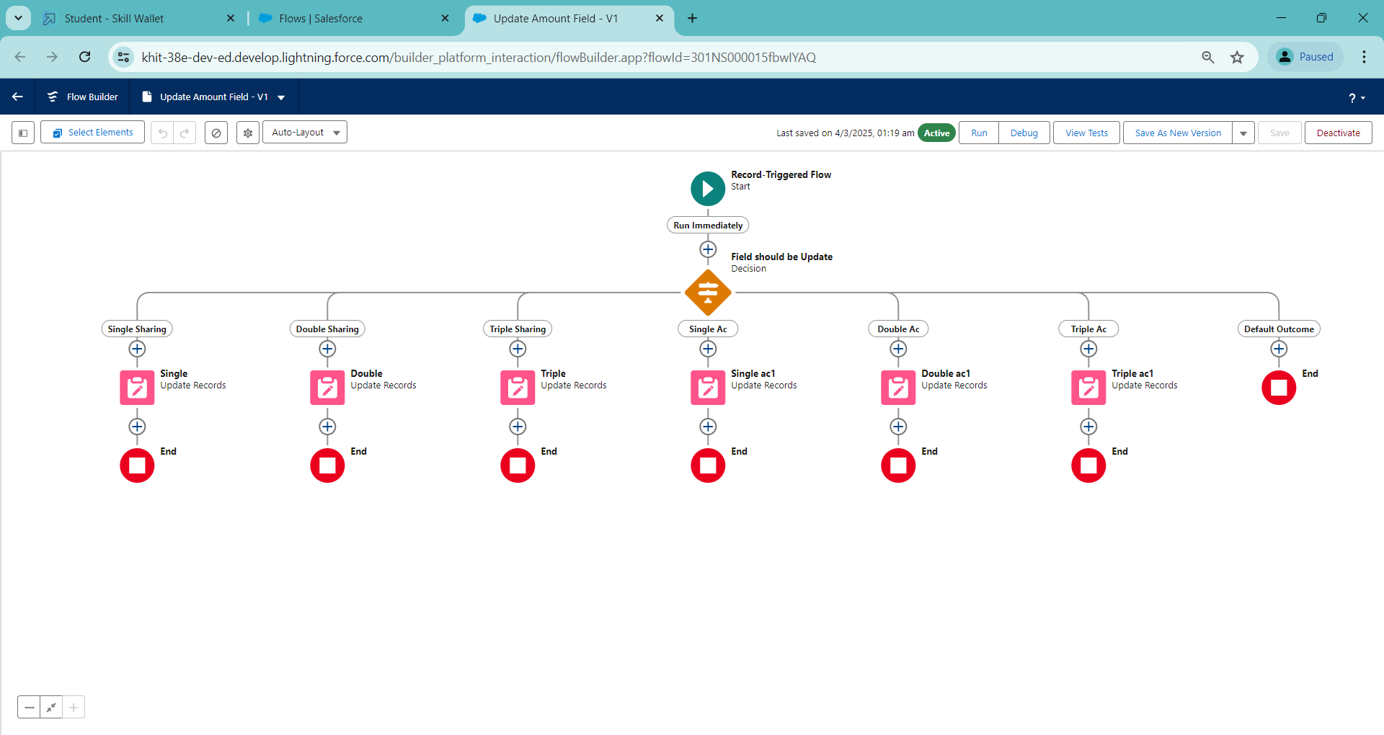

* + 1. **Testing the Flow**

Go to App Launcher and search for Co-living and select the app

In the Co-living app click on the Room sharing tab and click on new.

Enter the details like Name, Room sharing, Ac-3000, Advance payment for 1 Month. And the Amount field is empty before saving the record.

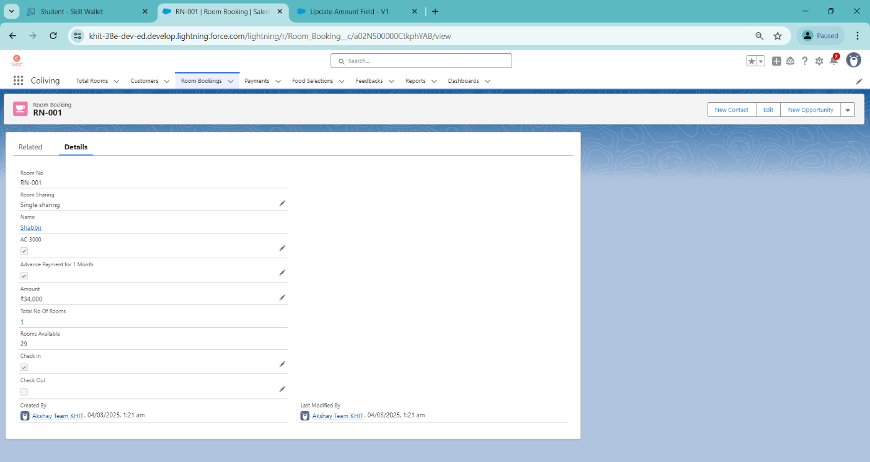

**OUTCOMES**

**A CRM application for managing co-living bookings** streamlines the entire tenant journey, from inquiries and reservations to move-in and ongoing engagement. By automating key processes such as booking confirmations, digital documentation, and payment tracking, the system ensures a hassle-free experience for both tenants and property managers. Real-time availability updates and an intuitive dashboard enable seamless property management, reducing manual efforts and minimizing errors.

Beyond bookings, the CRM enhances **tenant experience** by offering personalized communication, automated reminders, and easy access to support. Tenants can raise maintenance requests, track lease renewals, and receive important notifications via the platform, ensuring a smooth stay. Additionally, integrated payment solutions allow for automated rent collection and billing, eliminating delays and improving financial management.

From a business perspective, the CRM provides **data-driven insights** to optimize occupancy rates, forecast revenue, and enhance marketing efforts. Advanced reporting and analytics help property managers understand tenant behavior, refine pricing strategies, and improve retention rates. With scalability and third-party integrations, the CRM empowers co-living operators to efficiently manage multiple properties while delivering an exceptional living experience.

**CHALLENGES & SOLUTIONS**

**1. Handling High Inquiry Volume**

Managing numerous tenant inquiries manually can lead to missed opportunities and slow response times. Without automation, tracking inquiries across multiple channels becomes inefficient.

**Solution**:

Integrating an AI-powered chatbot and automated lead management system ensures instant responses and structured follow-ups, improving conversion rates.

**2. Inefficient Booking & Onboarding Process**

Manual booking processes can cause double bookings, delays, and administrative overload. Lack of real-time availability updates creates miscommunication.

**Solution:**

A CRM-integrated booking system updates availability in real time, automates document verification, and streamlines onboarding with digital processes.

**3. Payment & Rent Collection Delays**

Tracking rent payments manually can lead to inconsistencies, late payments, and cash flow disruptions.

* **Solution:**

Automated rent collection with reminders, multiple payment options, and penalty enforcement ensures timely transactions and reduces delays.

**4. Maintenance & Issue Resolution**

Unstructured maintenance request handling leads to delays, tenant dissatisfaction, and inefficient property management.

**Solution:**

A digital maintenance system allows tenants to submit requests online, assigns tasks automatically, and tracks progress for faster issue resolution.

**Key Scenarios Addressed for Salesforce on Implementation of Project**

**1. Inquiry & Lead Management**

* Capturing tenant inquiries from multiple channels (website, social media, email, phone).
* Automated lead scoring and assignment to sales representatives.
* AI-driven chatbots for instant query resolution and follow-ups.

**2. Booking & Tenant Onboarding**

* Real-time property availability updates to avoid double bookings.
* Digital document submission and verification for seamless onboarding.
* Automated contract generation and e-signature integration.

**3. Payment & Rent Management**

* Online rent collection with multiple payment options and automated reminders.
* Subscription-based billing for long-term tenants.
* Automated late fee calculation and penalty enforcement.

**4. Maintenance & Service Requests**

* Centralized system for tenants to log maintenance requests.
* Automated task assignment to service teams with status tracking.
* Notifications and updates to tenants on issue resolution progress.

**5. Tenant Engagement & Retention**

* Personalized communication through email, SMS, and in-app notifications.
* Community event management and referral programs to increase engagement.

**CONCLUSION**

A CRM application for managing co-living bookings provides a structured and efficient approach to handling tenant inquiries, reservations, payments, and ongoing engagement. By automating key processes, it reduces manual workload, minimizes errors, and enhances the overall tenant experience.

With features like real-time availability updates, digital onboarding, and automated rent collection, the system simplifies property management while ensuring seamless communication between tenants and operators. Additionally, data-driven insights help optimize occupancy rates and improve decision-making.

Overall, implementing a CRM system for co-living spaces supports better organization, improved tenant satisfaction, and sustainable business growth. By leveraging technology, co-living operators can create a more streamlined and engaging living environment.